*#*#**#**-if'*-s-**#*3-DIGIT 303 S22 PI BRECK H. CAMP CML 12/31/99 P0 BOX 47070

ATLANTA GA 30362-0070

he Official Publication of ALOA—An International Association of Security Professionals

**October 2002**

**Helping you stock up on the best tool values around**

**With: Basic locksmithing tools, picks, safe tools, automotive tools AC, personalized transponders and more.**

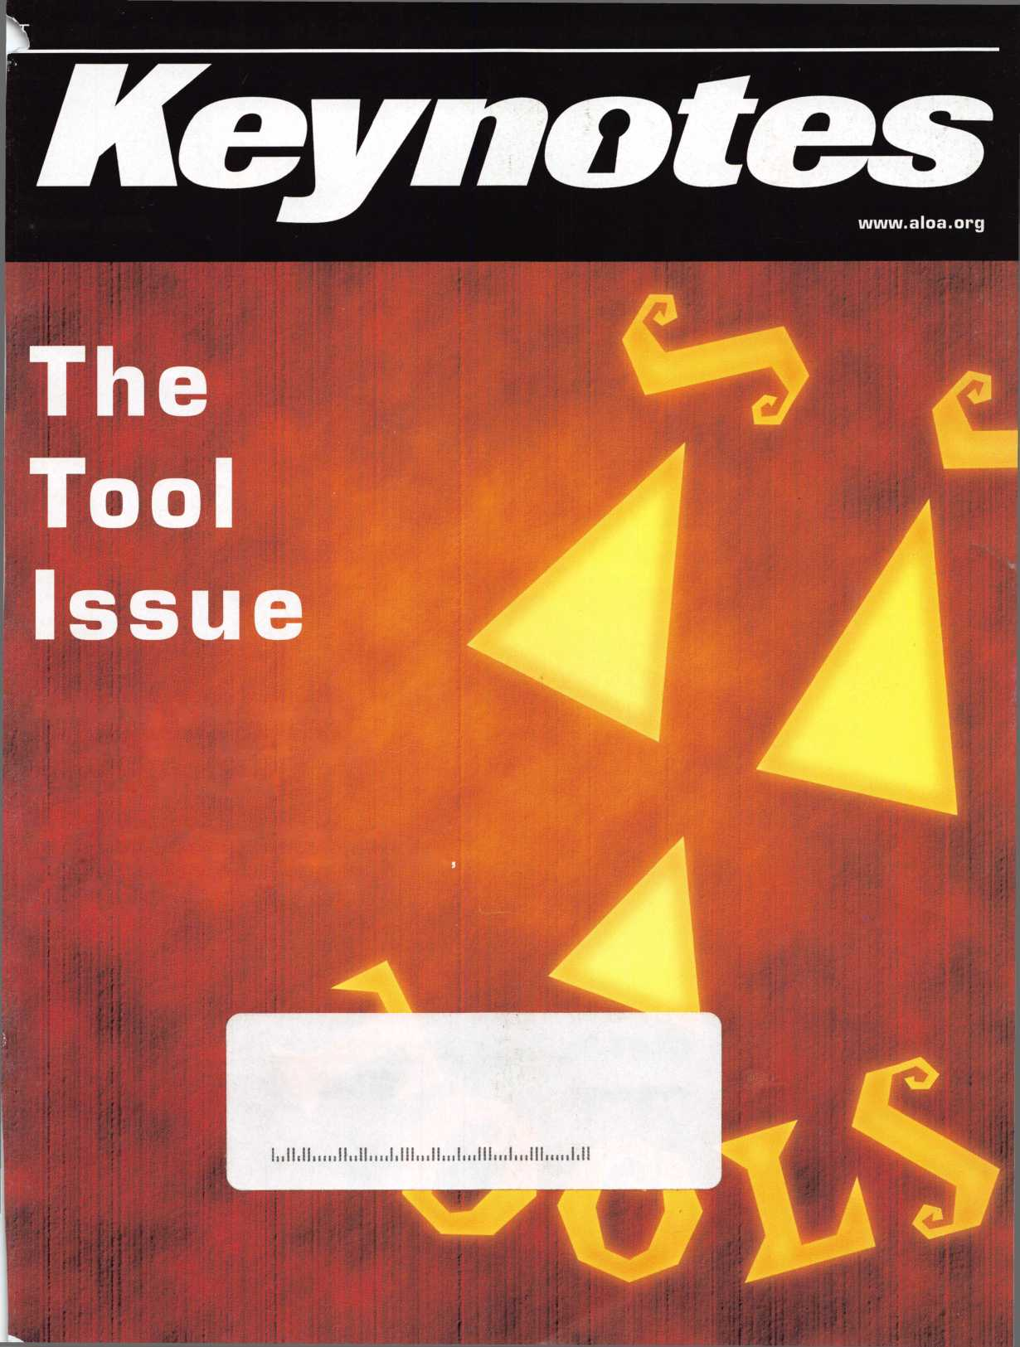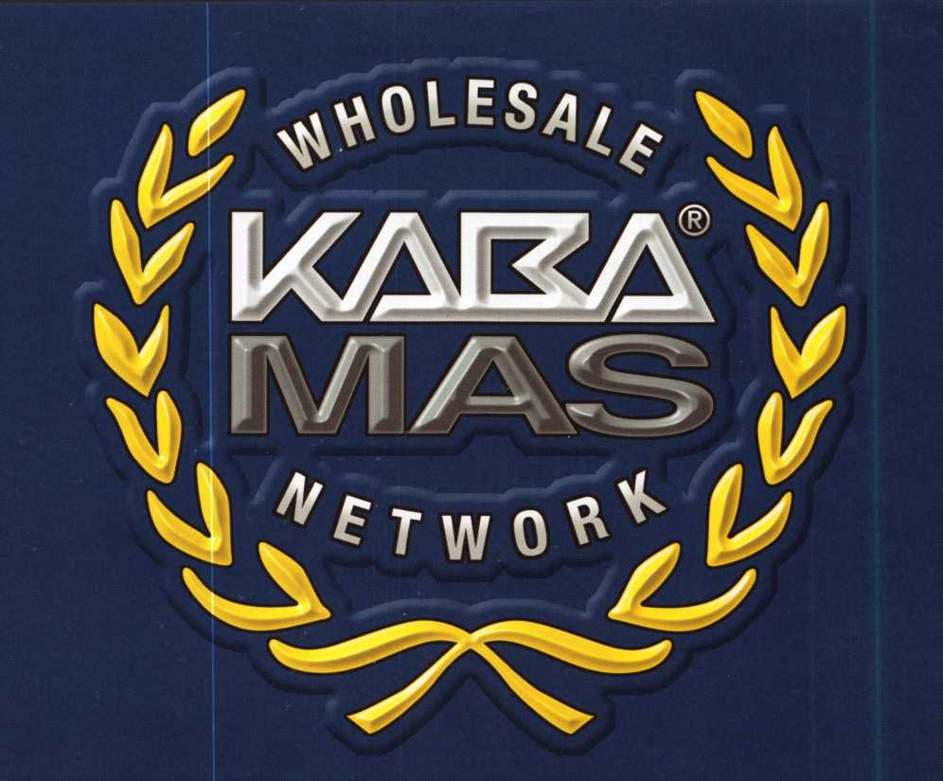

Introducing the Kaba Mas Wholesale Network. We are proud to have these wholesalers providing the full range of Kaba Mas products and services to our dealers, locksmiths and service centers.

|  |  |  |
| --- | --- | --- |
| Accredited Lock Supply Co.  800-652-2835  [www.acclock.com](http://www.acclock.com) | IDN Armstrong's, Inc.  800-726-3332  [www.idn-armstrongs.com](http://www.idn-armstrongs.com) | Locks Co.  800-288-0801  [www.locksco.com](http://www.locksco.com) |
| Akron Hardware  800-321-9602  [www.akronhardware.com](http://www.akronhardware.com) | IDN Hardware Sales  800-521-0955  [www.idnhardware.com](http://www.idnhardware.com) | Security Lock Dist.  800-847-5625  [www.seclock.com](http://www.seclock.com) |
| Clark Security  800-542-5625  [www.securerite.com](http://www.securerite.com) | IDN H.Hoffman  800-323-1918  [www.idnhoffman.com](http://www.idnhoffman.com) | Silver Sales  800-258-5625  [www.silversalesusa.com](http://www.silversalesusa.com) |
| Doyle Lock Supply  800-333-6953  [www.doylesecurity.com](http://www.doylesecurity.com) | IDN-West  800-525-3131  [www.idn-west.com](http://www.idn-west.com) | Southern Lock & Supply  800-237-2875  [www.southernlock.com](http://www.southernlock.com) |
| Fairway Supply  800-776-3247  [www.fairwaysupply.com](http://www.fairwaysupply.com) | Intermountain Lock Supply  800-453-5386  [www.imlss.com](http://www.imlss.com) | Timemaster Inc.  888-798-8465  [www.time-master.com](http://www.time-master.com) |
| IDN Acme, Inc.  800-788-2263  [www.idnacme.com](http://www.idnacme.com) | Lockmasters  800-654-0637  [www.lockmasters.com](http://www.lockmasters.com) | U.S. Lock Corp  800-925-5000  [www.uslock.com](http://www.uslock.com) |

**KARA**

MAS

Kaba Mas Corporation

749 W. Short St. • Lexington, KY 40508 USA  
toll-free 888-950-4715 • web [www.kaba-mas.com](http://www.kaba-mas.com)



Keep Your Day Job

Come to Las Vegas and invest in your future.

Discover classes, workshops, and exhibits that will keep you competitive in today’s marketplace.  
Las Vegas Hilton/Las Vegas Convention Center • July 14-20, 2003

LAS VEGAS, NEVADA

ALOA 2003

* ♦ T **I**

The only gamble is staying home.

**features**

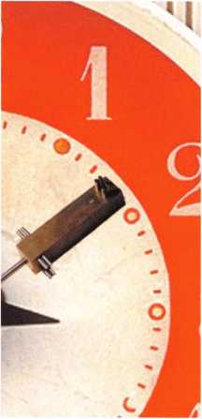

The Tool Issue

Cover



8 "Keys" to Lockmasters New Key Jewels

Eight reasons to love the latest in key innovation from Lockmasters.

Automotive

**14**

Lockmasters Latest Auto Tools

By Tom Seroogy and Randy Mize

Safes



Tool Time: New Tools from the ALOA Show By creg Perry, cml,cps

ALOA 2002 in Chicago really put the tools out there for those who wanted them. Let's review some of them, and consider if they might be right for you.

Basic Locksmithing

**22**

Peterson Picks (Basic Locksmithing) By Sal Dulcamaro, CML

A new pick manufacturer offers a gaggle of options for all of your picking needs.

Access Control

**26**

Inside Master's Digilock ByDaveThieien,cML

There are many battery-powered electronic lockers out there, and Master's new Digilock aims to find its niche with this easy-to-use, ADA-compliant system.



Institutional

Institutional: The Time I Spent in Jail By John Dorsey, cml, cps

One ALOA locksmith found that doing an assessment of the security systems in place at a  
Wisconsin jail was a life-changing experience.

**32**

Business

**36**

Give Your Advertising a Boost By Claire Cohen, CML

Ever wonder what you can do to enhance your advertising campaign? The steps to getting  
more bang for your buck might be more simple than you think.

|  |  |  |  |  |  |
| --- | --- | --- | --- | --- | --- |
| r |  | departments | |  | 1 |
| Executive  Calendar  L | 3 Applicants  6 Core | 8 Legislative  10 Update | Classifieds ...  38 Associate  Members | 40 Back Page ...  42 | 44  J |

Visit

our

w e

b s i t e at

WWW

a

I o a

o r g

Keynotes • October 2002

**executive**



Additional contact information for the ALOA Board and most Keynotes authors is  
available through "Locksmith Search'" on the ALOA Web site- [www.aloa.org](http://www.aloa.org) or by  
contacting the ALOA office at 3003 Live Oak Street; Dallas, TX 75204; (800)532-2562;  
FAX (214)827-1810; e-mail [aloa@aloa.org](mailto:aloa@aloa.org).

Editor Operations/Membership Manager

|  |  |  |  |
| --- | --- | --- | --- |
| Jim DeSimone | [edilor@aloa.org](mailto:edilor@aloa.org) | Mary May | [mary@aloa.org](mailto:mary@aloa.org) |
| Technical Editor |  | Director of Information Technology | |
| David Lowell, CML, CMST .... | [david@aloa.org](mailto:david@aloa.org) | Randy McChrislian | [randy@aloa.org](mailto:randy@aloa.org) |
| Editorial Advisor |  | Government Affairs Manager/ | |
| John D. Cannon, CML | .[jdcannon@worldnel.alt.nel](mailto:jdcannon@worldnel.alt.nel) | Chapters & Regional Associations Liaison | |
|  |  | Tim McMullen | [tim@aloa.org](mailto:tim@aloa.org) |
| Art Director |  |  |  |
| Belly Henderson | [belty@aloa.org](mailto:belty@aloa.org) | Comptroller | Kathy J. Romo |
| Advertising Sales |  | Network Specialist | Greg Jackson |
| Kim Hammond | voice: 817-645-6778  Fax: 817-645-7599 e-mail: [adsales@aloa.org](mailto:adsales@aloa.org) | Membership Coordinator | Shelly Jett |
|  | Convention & Meetings Assistant Karen Lyons | |
| Executive Director |  |  |  |
| Charles W. Gibson, Jr., CAE | [charlie@aloa.org](mailto:charlie@aloa.org) | PRP/Education Coordinator | Ashley Manson |
| Convention & Meetings Manager | | Accounting Coordinator | Stephanie Brothers |
| Kelly Carr, CMP | [kelly@aloa.org](mailto:kelly@aloa.org) | Mail Room Coordinator | Kevin Wesley |
| PRP/Education Manager |  |  |  |
| David Lowell, CML, CMST .... | [david@aloa.org](mailto:david@aloa.org) |  |  |
| Contributors |  |  |  |
| Jerome Andrews, CML | Sal Dulcamaro, CML | Mike Oehlerl, CPL, CPS | Tom Seroogy |
| Paul Chandler, CRL | Billy Edwards, CML | Randy Simpson, CML | Charles Stephenson, CPS |
| Claire Cohen, CML | Dan Graffeo, CRL,CMST | Robert Stafford, CML | Dennis Watanabe, CML, |
| Brian Coslley, CML, CMST | AJ. Hoffman, CML | Dave Thielen, CML | CMST |
| Ray D'Adamo, CML | Jeff Nunberg, CML, CMST | Greg Perry, CML,CPS |  |

Mission Statement: The Associated Locksmiths of America, Inc. is dedicated to enhancing the professionalism, education and ethics among locksmiths and those in related sectors of the physical security industry. With approximately 10,000 members in the United States, Canada and the freeworld, ALOA is poised to help members obtain the knowledge, the strength, and the confidence to perform their role in the physical security field with pride and dignity. But it is only through active involvement and participation that ALOA can fully achieve its potential—and can help members to achieve theirs.

Policies: Keynotes® is the official publication of the Associated Locksmiths of America, Inc. (ALOA). Keynotes® acts as a moderator without approving, disapproving, or guaranteeing the validity or accuracy of any data, claim, or opinion appearing under a byline or obtained or quoted from an acknowl­edged source. The opinions expressed by the authors do not necessarily reflect the official views of ALOA. Also, appearance of advertisements and new products or service information does not constitute an endorsement of products or services featured by the Association. The Association does not accept responsibility for the inaccuracy of any data, claim, or opinion appearing in this publication, due to typographical errors on the part of the authors, Association staff or its agents.

Editor's Note: This publication is designed to provide accurate and authoritative information in regard to the subject matter covered. It is provided and disseminated with the understanding that the publisher is not engaged in rendering legal or other professional services. If legal advice and other expert assistance is required, the services of a competent professional should be sought.

Authors' Payment: Payment for eligible submissions to Keynotes will be based on the following criteria: topic, time spent and past contributions. Authors who regularly submit to Keynotes® are generally paid a higher rate. The latter is especially true of authors who write to fit specific editorial needs and submit said copy by Keynotes® deadlines. As a general guideline: Average payment for a 750 word, business or 'light' technical article would be $200. Payment for a 1500 word article involving significantly higher time and research efforts would be $400.

Payment will not be offered for articles submitted by ALOA employees or members of the ALOA Board of Directors (unless material is of a technical nature), nor for articles submitted by a company that promote that company's products or services. ALOA reserves the right not to pay for articles sub­mitted by an individual(s) that promote a particular company's products or services.

Disclaimer: The Associated Locksmiths of America, Inc., (ALOA), reserves the right to refuse any article for any reason. Additionally, ALOA reserves the right to edit, amend or modify any article submitted for publication in order to preserve technical accuracy, clarity, fairness or grammatical cor­rectness. ALOA will make the best efforts to notify the author of any changes. The extent of ALOA's liability for any article or information contained therein will be a notice of correction or retraction in the next possible issue.

Keynotes® (ISSN 0277 0792) is published monthly except for the combined June/July issue by The Associated Locksmiths of America, Inc., 3003 Live Oak St., Dallas, TX 75204-6186. Telephone: (214) 827-1701; FAX (214) 827-1810; e-mail [aloa@aloa.org](mailto:aloa@aloa.org). Subscription rates for members—$15.00 per year. Second class postage paid at Dallas, Texas. POSTMASTER: Send address changes to: Keynotes, 3003 Live Oak St., Dallas, TX 75204-6186. © Copyright 1999, All rights reserved. No part of the contents may be reproduced or reprinted in any form without prior written permission of the publisher.

President

Randy Simpson, CML

1. 780-7026 president@aloa org

Secretary

John D. Cannon, CML  
(703)960-6413  
[secretary@aloa.org](mailto:secretary@aloa.org)

Directors, Northeast

Robert E. Mock  
(215)624-5035  
[nedirector@aloa.org](mailto:nedirector@aloa.org)

Peter Sarailian, CRL  
(973)890-9797  
[nedirector@aloa.org](mailto:nedirector@aloa.org)

William L. Young, CML  
■610) 647-5042  
nedi rector@aloa. org

Directors, Southeast

Vincent formon, CML, CPS  
(901) 324-2910  
sedirecfor@aloa. org

Donald E. Rule, CML

(662) 324-2658  
[sedirector@aloa.org](mailto:sedirector@aloa.org)

Directors, North Central

Mark E. Blum, CML, CPS  
(517) 482-5809  
[ncdirector@aloa.org](mailto:ncdirector@aloa.org)

John Soderland, CML, CMST  
(414) 327-5625  
ncdi rector@aloa .org

Director, South Central

CD Lipscomb, CML, CPS  
(903)874-3522  
scd i rector@aloa. org

Directors, Southwest

Gordon R. Racine, CML  
(719) 384-4707  
swdirector@aloa .org

Julie McCluney, CRL

1. 636-5652 [swdirector@aloa.org](mailto:swdirector@aloa.org)

Director, Northwest

Scott L. Henke, CRL, CPS  
(907) 248-3785  
nwdirecfor@alca .org

Director, European

Hans Mejlshede, CML  
(453)539-3939  
eurdirector@aloa .org

Director, Asian

JoeJ. Lee, CRL  
(215)289-2404  
[asiandirector@aloa.org](mailto:asiandirector@aloa.org)

Director, Associate

Paul M. justen  
(800)333-6953

[asdirector@aloa.org](mailto:asdirector@aloa.org)

Trustees

[trusfees@aloa.org](mailto:trusfees@aloa.org)

John J. Greenan, CML, CPS  
(773) 486.2030

Dallas Brooks  
(334) 826-8990

David M. Lowell, CML, CMST  
(800) 532-2562

Past Presidents

1999-2001 John Greenan, CML, CPS  
1997-1999 Dallas C. Brooks  
1995-1997 David Lowell, CML, CMST  
1993-1995 Breck Camp, CML  
1991-1993 Henry Printz, CML  
1989-1991 Evelyn Wersonick, CML, CPS  
1987-1989 Leonard Passarello, CPL  
1985-1987 Joe Jackman, CML  
1983-1985 Stanley Haney, CPL  
1981-1983 Louis LaGreco, CPL  
1979-1981 John Kerr, RL  
1977-1979 Clifford Cox, CML  
1974-1977 Charles Hetherington  
1972-1974 Gene Laughridge  
1970-1972 William Dutcher, RL  
1968-1970 Constant Maffey, RL  
1966-1968 Harold Edelstein, RL  
1964-1966 William Meacham  
1962-1964 Robert Rackliffe, CPL  
1960-1962 Edwin Toepfer, RL  
1956-1960 Ernest Johannesen



Keynotes • October 2002

president's

**journey**

Hello Members,

Tools, tools and yet more tools. They seem to make the locksmith's world go around. The right tool can save you so much time and make you so much money that you end up wondering how you ever lived without it. We cover tools throughout the year (and allow manufactuerers to display them prominently at our shows each year for the ben­efit of you, our members), but this issue of Keynotes is dedicated specifically to tools. As a professional locksmith, it's never a bad idea to stop and consider what your favorite tool is, or perhaps the tool that helps your business profit more than the other tools are able to do, depending on the focus of your business. My favorite tool is an ITL 9000. It was manufactured in 1981 and has cut well over 100,000 keys. It has per­formed well with only an occasional day of down time while waiting on parts from its manufacturer. After multiple updates, I am receiving some hesitation from the manu­facturer about continuing to repair it. They would like for me to retire it and buy a new one. But why would I do that? It's my favorite tool.

Key machines aside, no matter which area of specialty we find ourselves in, tools can make so many differences in time and profitability. It's worth your while to hunt for those one or two special tools out there that can really make a positive change in your busi­ness. I trust that you each have your own favorite tools, and I hope that they help you make some money - and cut down on your headache factor!

See you next month,

Randy Simpson, CML



Keynotes • October 2002

Huailable as single  
modules (one CD and  
guidebook) or the full  
set (three CDs and  
three guidebooks).

Seruer uersions are  
also auailable!

Architectural Doors

*Fundamentals Self-*

*and Hardware*

Study Course ^

FUNDAMENTALS OF

**Self-Study Course**

HLOH

**SPECIRL**

**Get the award-winning  
*Fundamentals of architecture  
Doors and Hardware Self-Study  
Course* at a great price!**

The ultimate training tool for locksmiths... Nom there is a complete in-house training

**program auailable! Order the** Fundamentals of architectural Doors and Hardware Self

**Study Course** three CD/guidebook series.

To order, call (800)532-2562 or [www.aloa.org](http://www.aloa.org)

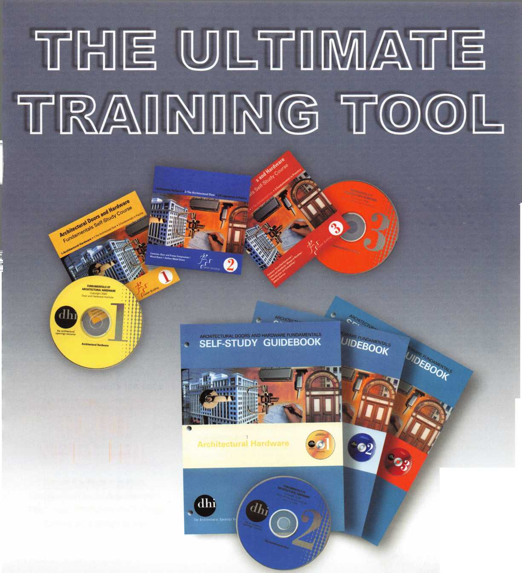

**DEC I NOV OCT**

u

p

o m

Minnesota Chapter of ALOA Membership Meeting Basic Lock Cylinder Rekeying [www.locksmithnews.com](http://www.locksmithnews.com)

1-5 Pacific Locksmith Association Annual Convention Portland, OR 541-741-6902 [www.pla-pro.org](http://www.pla-pro.org)

3 Oregon Professional Locksmith Day Banquet

n g

16 Central Florida Locksmith Assn. Membership Meeting 7:30pm Contact: Janet Boyer 386-775-3641

|  |  |  |  |
| --- | --- | --- | --- |
| 2-3 GHLA | 6 Minnesota Chapter of ALOA | 6-10 Yankee Security Conference 9 | Wisconsin Indianhead Chapter of |
| Safe Deposit Lock Svc. | Membership Meeting | Sturbridge, MA | ALOA • Membership Meeting |
| with Ken Foo, CPS | [www.locksmithnews.com](http://www.locksmithnews.com) | Jack Hobin, CPL • 413-565-5152 | Kenneth Briggs 715-726-0687 |
| Ed Stites 979-323-9919 |  | [www.yankeesecurity.org](http://www.yankeesecurity.org) |  |
| [ditels@fbtc.net](mailto:ditels@fbtc.net) |  | See ad pg. 35 |  |

4 Minnesota Chapter of ALOA First Annual Banquet Shorewood Restaurant ($25) Alan Morgan, Jr. [alanmorgan@aol.com](mailto:alanmorgan@aol.com)

7 Pacific Locksmith Association "How To Make Money from Stolen Cars Without Stealing Them" Class <http://www.pla-pro.org>

1 8 Central Florida Locksmith Assn.

Membership Meeting 7:30pm Janet Boyer 386-775-3641

UPCOMING PRP SITTINGS

Oct. 11 ALOA • Dallas, TX • Ashley Manson: 800-532-2562, ext. 30

Oct. 13 Ohio Valley Chapter of ALOA

Dayton, Ohio • Bill Lockwood, CRL 937-836-6127

Oct. 19 GA Chapter of ALOA Chamblee, Georgia John C. Elliott, Jr., CML, CPS 770-385-9753

Oct. 27 GPLA • Mount Laurel, PA

William Young, CML • 610-647-5042

Nov. 8 ALOA • Dallas, TX • Ashley Manson: 800-532-2562, ext. 30

Nov. 9 Yankee Security Conference and Trade Show (see ad page 34)

Sturbridge, MA • [www.yankeesecurity.org](http://www.yankeesecurity.org) 800-209-8266

Nov. 16 Grand Canyon Chapter of ALOA Phoenix, AZ • John Ilk, CRL, CPS: 602-420-2174

Dec. 8 Allied Locksmiths of Youngstown Youngstown, OH •

Tony Ramunno, CML, CPS 330-782-6204

Dec. 13 ALOA • Dallas, TX • Ashley Manson: 800-532-2562, ext. 30

UPCOMING ACE CLASSES

Oct. 1-4 Pacific Locksmiths Association Karl Kretsch • 541-926-3525 12 Ace Classes <http://www>. pla-pro.org

Oct. 1 9 Northern Prairie Chapter • Fargo, ND

Todd Ladwig, CML, CPS • 701-232-9440 Hollow Metal Door and Frame Servicing [todd@curtslock.com](mailto:todd@curtslock.com)

Nov. 6-9 Yankee Security Convention

Sturbridge, MA • See Ad Page 34 800-209-8266

Nov.

16-17 Georgia Chapter of ALOA • John Elliot Sr., CML, CPS Atlanta, GA • Comprehensive 1C I & II (2 days)

Nov. 23 Alabama Locksmiths Assn. • Birmingham, AL Amanda Floyd • 334-793-5060 Electronic Safe Lock Svc.

2003 ACE Classes

Jan. 1 1 Wyoming Locksmiths Association

Casper, WY • Investigative Locksmithing I Gener Ficek, CPL • 605-642-4542

Feb.

22-23 Alabama Locksmiths Assn.

Basic Electricity and Intro to Access Control Amanda Floyd • 334-793-5060

Feb 28 -

Mar. 1 Minnesota Chapter of ALOA

Maplewood, MN • Dana Lee, CML 612-722-9181 • [Ill7@qwest.net](mailto:Ill7@qwest.net) Comprehensive 1C I & II (2 days)

Servicing Aluminum Storefront Doors Life Safety Codes and ADA

Mar. 3-7 Fox Valley Technical College • Appleton, Wl Jerry Antoon: 920-735-2406 [www.fvtc.edu](http://www.fvtc.edu) • See ad facing page

Apr. 24-26 Denver, CO • 9 Classes

May 17-1 8 Alabama Locksmiths Assoc

Birmingham, AL • Import Automotive I & II



**events**

|  |  |  |  |
| --- | --- | --- | --- |
| 18-19GHLA | 23-27 Greater Philadelphia Locksmith | 25-26 South Carolina | 26-27 California Locksmith Assn. |
| Auto Opening/Svc | Association (G-PLA) Convention | Locksmith Assn. Meeting | Convention and Membership |
| with Jim Hetchler |  | (803} 432-9009 | Meeting • Town and Country |
| Ed Stites 979-323-9919 |  |  | Hotel • San Diego |
| [ditels@fbtc.net](mailto:ditels@fbtc.net)  SbS |  |  | Jack Lindstrom 760-364-4421 |

|  |  |  |
| --- | --- | --- |
| 20 Central Florida Locksmith Assn. | 23 GHLA | 27 Pacific Locksmith Association |
| Membership Meeting 7:30pm | Interchangable Cores | Membership Meeting |
| Contact: Janet Boyer | with Buddy Clifford | Tualatin, OR • 6:30pm |
| 386-775-3641 | Ed Stites 979-323-9919 [ditels@fbtc.net](mailto:ditels@fbtc.net) | http:/ / [www.pla-pro.org](http://www.pla-pro.org) |

Locksmith Training

Sponsored by Fox Valley Technical College • 1825 N. Bluemound Dr. • Appleton, Wl 54912-2277

6-Day Program • Career Change in One Week • March 3-7, 2003

This is a basic locksmithing training course sponsored by FVTC’s Security and Crime Prevention  
Department and conducted by ALOA ACE instructors. Designed for the locksmith shop owner  
who would like to provide entry-level training for new apprentice locksmiths as well as those who

would like to receive professional training that will enable employment with a professional locksmith. The course will allow the student  
to gain enough knowledge to make them a starting apprentice in an existing shop. Job placement locations will be made available at the  
time of the class.

To maintain quality the course enrollment will be capped at 12 students. Enroll early!

Curriculum includes:

Key Blank Identification and Duplication Key Codes and Code Equipment Basic Master Keying

Lockset Servicing, Functions, Finishes

Life Safety Codes

Lock Pick Opening Techniques

Pin and Disc Cylinder Servicing Key Impressioning

Lock By-Pass Techniques Exit Flardware

Door Closers

Lockset Installation

Cabinet, Furniture, Mailbox Locks

All tools and equipment will be made available for use during training. Class Hours: 8:30 am to 5:00 pm every day Class Attire: Shop clothes Course Tuition: $995.00

Course Enrollment: See Susan Egnoski in the Criminal Justice Center

or call 920-831-4393

Note: Enrollment deadline is Friday, September 20, 2002



AZ

IN



p I i c a n t s

membership

Chandler

Meredith A. Herbert III

Sponsor: Enrique B. Olivares

***CT***

Branford

Donald Crockford-Peters

FL

Jupiter

Dwight Orrell

Port Charlotte

Zachary Gilmore

Sponsor: Keith LeRoy

GA

Evans

Rick E. Peterson

Sponsor: Brooke P. Berry CRL

Marietta Tony Whalen

Sponsor: Bruce P. Eagan CML

McDonough

Richard D. Connerly

Sponsor: Danny W. Rudd CPL

IL

Springfield

David R. Schmidt

Clay City

Brian E. Van Den burgh

Crown Point Brian Pante

Sponsor: Alfred J. Pante CPL

Valparaiso

Raymond D. Wood Jr

Sponsor: Edward R. Woods CRL, CPS

MA

Hingham Robert R. Cullum

Sponsor: Clyde T. Roberson CML, CPS

ME

Bangor

Winfield F. Murray

Sponsor: Robert B. Cross, Jr

MS

Pearl

Joe R. Thweatt

Sponsor: Robert J. Bosi Jr, CML, CPS

OH

Wheelersburg

Steven M. Easter

Sponsor: Charles E. Fannin

OK

Owasso

Barton L. Snow

Sponsor: Rodney J. Peterson

PA

Harleysville Edward Sellers

Sponsor: Michael B. Groves

Philadelphia

Louis Imbesi

TN

Kingsport

Henry C. Peters Jr

Sponsor: John W. Soderland CML, CMST

TX

Arlington

Miguel A. Nieves

Mineola James L. Price

Sponsor: James P. Pritchett, CPL

VA

Arlington

Mitchell Gelman William Walker

Wl

Appleton

Steve Collins

Sponsor: John W. Soderland CML, CMST New Auburn

Forsell Gappa

Sponsor: Kenneth W. Briggs

Canada

Nova Scotia

Donald H. Weatherdon

Korea

Seoul

Young-Dae An Suwon Kyouggi-do Kwang Hee Han

Mexico

Monterrey

Juan D. Villarreal Trevio Tlalnepantla Edo Felipe S. Arce

Venezuela

Caracas

Jose A. Rodriguez

Sponsor: Clifford D. Lipscomb CML, CPS

These applicants are scheduled for clearance as members of ALOA. The names are published for member review and comment within  
30 days of this Keynotes issue date, respectively, to ensure applicants meet standards of ALOA's Code of Ethics. Protests, if any, should  
be addressed to the Membership Department and must be signed. Active Membership applicants (a) have worked in the industry two or  
more years. Allied Membership (AL) applicants are not locksmiths, but work in a security-related field. Apprentice Membership (AP)

applicants have worked in the industry less than two years.



Keynotes • October 2002

**Renew or Apply for Membership ONLINE at [www.aloa.org](http://www.aloa.org)**

**During times of crisis, unity is key. Right now, when you join ALOA  
(or renew your membership), you will receive, free of charge,  
this patriotic decal for your shop or van, which serves as a  
special reminder to you and your customers that it takes  
a spirited effort to strengthen the ties that bind us.**

HLUH Locksmiths

Secure America

**Decal dimensions 872" x 5%"**

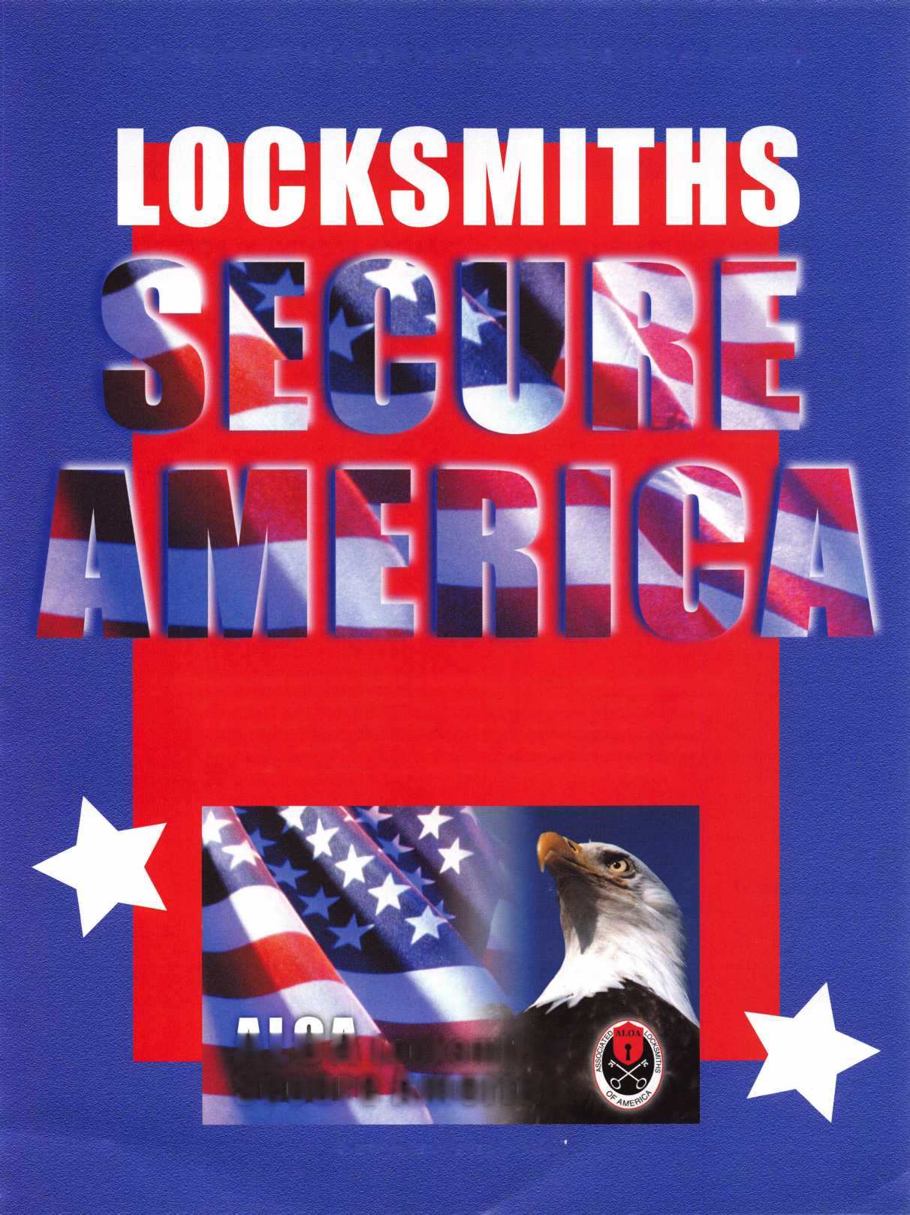

core

CONTACT YOUR REPRESENTATIVE TODAY REGARDING

"The Motor Vehicle Owner's

Right to Repair Act **of** 2001" (H.R. 2735)

Last year Representatives Joe Barton and Edolphus Towns introduced "The Motor Vehicle Owner's Right to Repair Act of 2001". The legislation will require the Federal Trade Commission to prescribe and enforce rules necessary to ensure the right of a motor vehicle owner to obtain all infor­mation required for the diagnosis, service, and repair of the motor vehicle in a timely, affordable, and reliable manner. Although the bill does not specifically say what information must be provided, we are working with the after-market industry to ensure that the information you need to service any vehicle is released.

The push for this bill has now moved from the Senate to the House of Representatives. ALOA is working with the Coalition for Auto Repair Equality to get a hearing on this bill THIS MONTH before Congress leaves for the elections.

PLEASE FAX YOUR REPRESENTATIVE ON THE SUBCOMMITTEE TODAY BY GOING TO

<http://www.aloa.org/news/legcom.cfm>.

If your state is not listed, we still need you to send a letter to Rep. Cliff Stearns, Chair of the Subcommittee.

Even if you don't do any automotive work, please send a let­ter regardless. ALOA has written letters to all the Subcommittee members, but we need your help. Please fax your letter TODAY!

Please email a copy of your letter to the ALOA office at [tim@aloa.org](mailto:tim@aloa.org) or fax at 214/ 827-1 810 for our records.

THANK YOU IN ADVANCE FOR YOUR SUPPORT!

Let Us Know!

If you have an opinion to offer on ALOA, the state of the industry, or life in general, we want to know about it! Submissions to the "Mailbox" section of Keynotes are printed on a space-available basis. Write to: "Letters to the Editor"; ALOA; 3003 Live Oak Street; Dallas, TX, 75240; FAX 214/827-1810; e-mail: [editor@aloa.org](mailto:editor@aloa.org).

ALOA's POSITIVE ID POLICY:

* ALOA locksmiths are instructed to use the following posi­tive identification policy when servicing lockouts:
* Notify Caller. When a call comes in to request lockout services, ask the caller if he/she has identification and authority to open the lock.
* Complete Form. Upon arrival at the job site, the lock­smith should complete an Authorization Form that asks for the name, address, phone number, identification number and property description from the customer.
* Verify I.D. Verify the customer's photo-identification card and compare it to the information provided by the cus­tomer. If no photo-ID card is available, ask for some other reasonable form of ID.
* Verify Authority. The locksmith should inquire as to what authority the customer has to open the lock, and request to see any reasonable and appropriate evidence that could verify the authority. This may be impossible in some cases.
* Ask for Signature. Ask the customer to sign the Authorization Form, which should contain a statement that (a) the information given by the customer is correct,

1. the customer has the authority to open the lock, and
2. the customer shall identify and hold harmless the lock­smith against liability.

* Optional Last Resort. If you have any suspicions that the customer is giving false information or does not have authority to open the lock, say that you will be happy to open the lock provided a law enforcement officer is present. If the customer agrees, call the police; if not, leave.
* File the Form. Keep the Authorization Form on file for a reasonable period of time.

Need Help?

At ALOA, we want to make sure you are getting as much bang for your membership dues buck as we are able to give you. If you have had problems getting membership services, or have a question regarding member services, please con­tact Bill Gibson, executive director, at 800/532-2562, or e- mail: [charlie@aloa.org](mailto:charlie@aloa.org).



Keynotes • October 2002

New Certifications

CMLs

Kevin Wilson

CPLs

William Cochran Michael Lehnert Robert Rodocker

CRLs

Tony Ashley Douglas Bailey Hobert Banks Brooke Berry Dan Billheimer Scott Brandom Peter Cordaro John Crump Robert Dennee

Christopher Wayne Guillory

Bret Krist Gerald Manero Debra Mersch Robert Palka Jr. Daniel Rossi, Jr. Terry Sharkey David Taylor Joann Taylor Hank Tenenbaum Peter Thompson

Lilburn, GA

Hayward, Wl Aurora, IL Fort Wayne, IN

Springfield, VA Houston, TX Jefferson, TN Nicholasville, KY Mansfield, OH Colona, IL Olney, MD Melean, VA Marshfield, Wl

Montgomery, TX Calumet City, IL Chicago, IL Argos, IN Chicago, IL Lancaster, PA Momence, IL Ada, OK Cincinnati, OH Fairfax, VA Madison, Wl

Don't Stay a Secret!

ALOA Members - we want to tell customers

all over the world about you. Help us by filling out  
a simple questionnaire for our all-new, expanded web  
search engine for members of the general public seeking  
locksmith services. The new search engine is designed:

* To provide potential consumers more specific infor­mation about ALOA members and the services you provide.
* As a base of specific information regarding a mem­ber's business, only those who provide information will be included in this new Locksmith Business Search area.
* The search will be updated by members who submit specific change instructions. This info will not be linked to their individual membership records.

More information about you will be going to future  
customers as a result of you filling out this simple form.

Go to [www.aloa.org](http://www.aloa.org)

or simply call us at 800/532-2562 for more info.

Keynotes • October 2002

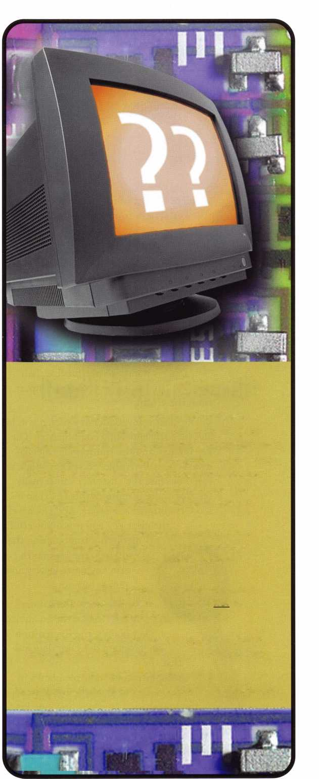

to Lockmasters’  
New Key Jewels



Here is a list of the perks of an all-new  
key system from Lockmasters:

1. Not unlike the enameled keyblanks  
   available in the industry the per-  
   ceived value of the key when bejew-  
   eled increases. When you take a prod-  
   uct that has relatively little or no

aesthetic value and make it look  
better, people are immediately  
drawn to it.

1. Consumers love an oppor-  
   tunity to personalize their  
   items, to set themselves apart  
   crowd.

from the

1. The clear transponder key with a jewel is  
   an especially appealing combination. The  
   key is clear, and the transponder mecha-  
   nism is actually visible. So sticker shock is  
   eased because the customer can actually  
   see that there is more to this key than a  
   more traditional key offers. Add the jewel  
   to the clear key and it is a powerful

marketing combination that  
will help the locksmith  
gain customer loyalty and  
repeat business.

1. Decreased inventory  
   needs. Unlike the enameled  
   key blanks, the Recignition

key program does not demand  
that the

locksmith stock multiple blanks in

order to realize the benefits. Instead,  
the inventory scenario is now one key -  
20 options for that particular key.  
Locksmiths do not necessarily  
have to stock all 25+ keys with all  
20+ jewels.

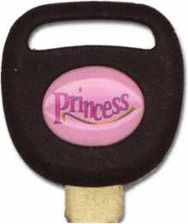

1. Personalized key jewels better enable the locksmith to sell multiple keys. For exam­ple, a man goes to the local locksmith to get keys, and immediately realizes that the jeweled keys are unique. He decides to get one for his wife, and for his teenage daugh­ter, each with a different jewel.
2. When the locksmith utilizes personal­ized key jewels (with the shop name and phone number), he or she realizes a very inexpensive way to advertise - and with great frequency. The shop’s logo jewel is placed on one side of the key, and the cus­tomer chooses which jewel for the other side (all keys in this program accept jewels on both sides). This can be done for around $.20 per jewel, but remember how many times car keys are laying around for others to see. It turns out to be much less per key than $.20 when you figure the frequency with which the message will be viewed.
3. An additional selling tool for locksmiths is the unique nature of the keys for ID pur­poses - so customers can eliminate the “Are those your keys or mine?” issue.
4. Jewels can be used for multiple purposes. Anywhere the customer wants to personal­ize whether it be cell phones, car interiors, computers, digital cameras... they look great! Q

**2**

Keynotes • October 2002

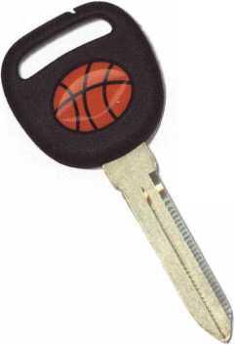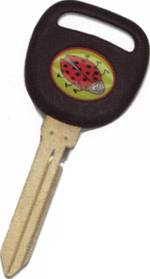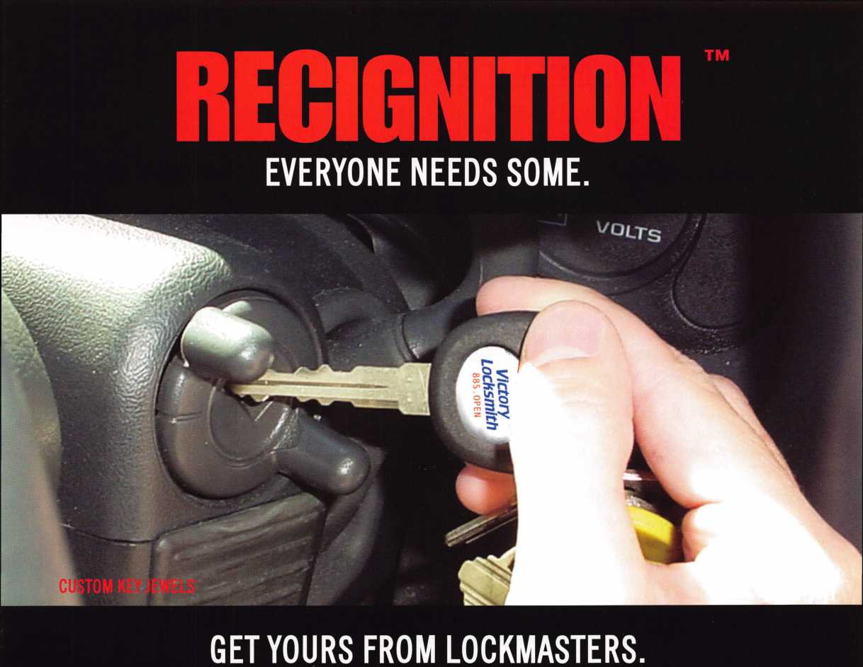

Lockmasters' unique key jewel program, recIGNiTION™, allows  
your customers to customize their keys with our standard key  
jewels, as shown on the right.

Or for just pennies you can put your logo on every key  
you cut, as shown above.

Our key blanks are specially designed to accept a custom  
jewel on both sides. Keys available in non-transponder and  
transponder automotive keys for Ford, GM, Chrysler, Honda,  
Mitsubishi, Nissan & Toyota.

GET 1,000 CUSTOMIZED KEY JEWELS FOR AS LITTLE AS $425.



GNIIION

**TM**

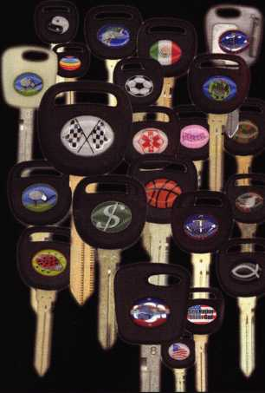

**800.654.0637**

FOR MORE INFORMATION VISiT[WWW.RECIGNIT10N.C0M](http://WWW.RECIGNIT10N.C0M)

Transponder Update

New Outlook from Lockmasters By Tom Seroogy and Randy Mize



Lockmasters is currently wrapping up its first year of the PUREAuto Automotive Weekends, and throughout this year, we’ve found that one thing is certain - the automotive industry is not standing still. So, in the ongoing battle to keep up with the ever-changing world of automotive lock technology, we’ve assembled this short list of changes that have occurred over the last year. Some are well known, others not so well known.

GM Introduces PKIII Plus

Based on its current transponder technology, PASS Key III (PKIII), GM made revisions in programming that confused the dealer as well as the locksmith. The change affects 2001+ PKIII-equipped GM “Export” vehicles. “Export” by GM’s definition is any vehicle that is produced for export to another country. That is, a GM vehicle produced in Canada or Mexico for sale in the United States is considered an “Export” vehicle.

The locksmith can easily determine whether a GM is con­sidered an Export by looking at the first digit of the Vehicle Identification Number (VIN). This digit reveals the vehicle’s country of origin. The number “1” is assigned to the United States, “2” to Canada and “3” to Mexico.

When working on a late model PKIII-equipped GM, if the first digit of the VIN is a “2” or “3,” it is considered an Export vehicle and employees the PKIII Plus system.

The major difference between the PKIII and the PKIII Plus systems is in the procedure for adding duplicate keys using onboard programming. The standard PKIII system required one working master key PKIII Plus requires two working master keys.

To add keys for a PKIII Plus vehicle:

1. Insert first programmed master key into ignition and turn to ON. Wait two seconds, turn ignition OFF and remove key.
2. Insert second programmed master key into ignition and turn to ON. Wait two seconds, turn ignition OFF and remove key.
3. Insert unprogrammed duplicate key into ignition and turn to ON. Wait two seconds, turn ignition OFF and remove key.

If only one key is available or keys do not exist, new keys

can be generated using the standard onboard PKIII key

generation procedure.

1. Cut a master key, insert into the ignition and turn to ON.
2. Wait 10 minutes and cycle ignition OFF-ON.
3. Wait another 10 minutes and cycle ignition OFF-ON.
4. Wait another 10 minutes then turn ignition OFF and remove key.

To add second master key:

1. Within 20 seconds of removing first key, insert a second master key into the ignition.
2. Turn ignition ON, wait 2 seconds and turn OFF. Remove key.
3. To program additional keys, insert next master key with in 20 seconds of removing last key and cycle ignition ON-OFF. Up to 12 keys total can be programmed.
4. Valet keys can be programmed at any time after second master key is programmed, but stops programming mode once it is programmed.



Keynotes • October 2002

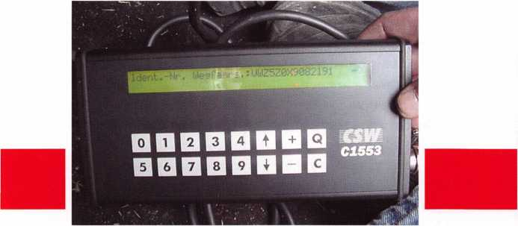

photo 1

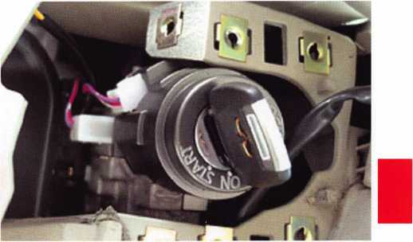

photo 3

Volkswagen/Audi

Over this last year, VW and Audi changed the programming requirements for their transponder system from a 4-digit PIN or LOGIN to a 7-digit number. Although the 7-digit PIN is the only number available from a VW/Audi dealer, the vehicles themselves still only use 4-digits. (See photo­graph 1.) In practice, the 7-digit PIN is entered into the diagnostic tool where it is converted to a 4-digit PIN that is actually sent to the vehicle’s ECU. In essence, if a lock­smith knows the correct 4-digit PIN, he or she can us it to program the vehicle.

The magic doesn’t stop here, however. The conversion process from a 7-digit to a 4-digit PIN is a little more elaborate than it appears. The 7-digit PIN is actually based on the current date, the WSC (Workshop Code or dealer number) and an import number (444 for the United States). If any criteria change - date, WSC or import number - the 7-digit PIN changes.

Making matters a little tougher, except for the VW/Audi dealer tool and Ross-Tech’s VW software package, most aftermarket diagnostic tools only accept the 4-digit pin.

As such, the locksmiths working on VWs or Audis are left wanting for a method or means of converting the 7-digit PIN to 4-digits. Keep in touch with Lockmasters for the availability of 4-digit PINs.

Infiniti

2001+ Q45

The Q45 was introduced as the “keyless” car, using a transponder based remote key fob to open and start the vehicle. It was later found that the ignition lock not only accepted the specially designed key fob, but also the stan­dard Infiniti transponder key. And, despite first appearances, a standard blue covered Infiniti transponder key can be pro­grammed and used to operate the vehicle. (See photographs 2 and 3.)

2002 G35

The G35 introduced a slight change in Infiniti’s transponder programming procedure. Previously, Infiniti programming required a 4-digit PIN number that, up to this date, was the same for all applications. With the introduction of the G35, however, the PIN is vehicle specific or different for every G35. To obtain the number, the locksmith must request the PIN from the dealer based on the vehicle’s VIN. (See pho­tograph 4.)

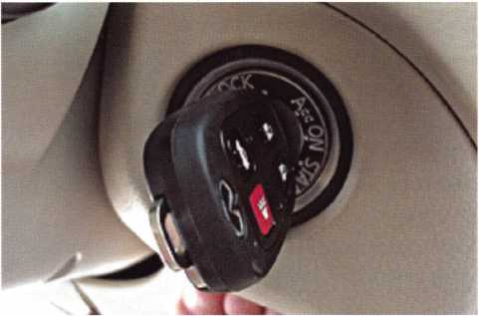

photo 2

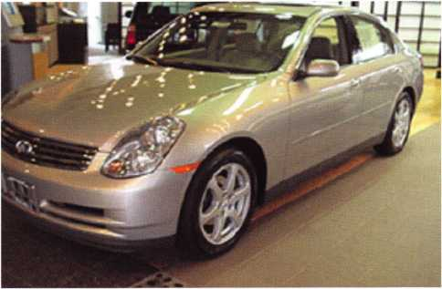

photo 4

Keynotes • October 2002

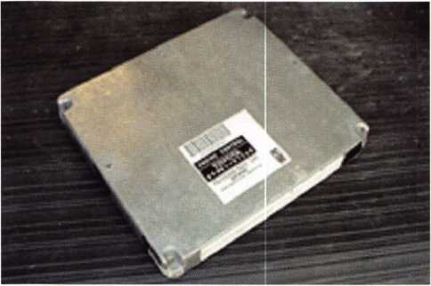

photo 5

Toyota

Up to 2001, the only way to generate new keys for a transponder-equipped Toyota was to remove and replace (or reprogram) the ECU. (See photograph 5.)

From late 2001 and into 2002, however, Toyota has intro­duced a new ECU that allows keys to be programmed using the Toyota diagnostic tool. Although to date, this tool is not readily available, Lockmasters can still provide ECU reprogramming on these models.

For these vehicles, new onboard programming procedures are also used.

For key duplication using onboard programming:

1. Start by closing driver’s door without key in ignition.
2. Insert programmed master key into ignition.
3. Cycle lock ON-OFF 5 times.
4. Open/Close driver’s door 6 times.
5. Remove master key from ignition.
6. Insert duplicate key.
7. Wait for THEFT light to go out - about 60 seconds. Key is registered.

Mitsubishi

Mitsubishi added an emergency bypass procedure to their vehicles. This procedure allows temporary bypass of the transponder requirement, allowing a standard mechanical key to operate the vehicle. This procedure requires a PIN number, available only through a Mitsubishi dealer. The PIN must be entered for each time the vehicle is started using a mechanical key This procedure can only be used twice before the PIN number automatically changes, requiring the dealer diagnostic tool to determine the new PIN number.

Bypass Procedure:

1. Obtain bypass number from Mitsubishi dealer.
2. Insert mechanical key into ignition and turn to ON.
3. Security light will come ON after 5 seconds.
4. Wait for security light to go OUT - about 30 seconds. PIN Code can now be entered.
5. Depress brake pedal the number of times of the first digit of the PIN number. Ex: if first digit of PIN is “3,” depress brake three times.
6. Wait a few seconds, but not more than 30 seconds.
7. Repeat steps 5 and 6 for each digit in the PIN.
8. If entered correctly, the Security light will blink.
9. Cycle ignition lock OFF-ON within 7 seconds of light going out.

Along with the bypass feature, Mitsubishi has also integrat­ed onboard procedures for adding extra or duplicate keys onto their 2002+ models. This procedure will add keys without erasing the other keys that currently operate the vehicle. Like other manufacturers that have onboard pro­gramming procedures, Mitsubishi requires 2 working or programmed master keys to begin. To add keys use the fol­lowing procedure:

1. Insert first programmed key into ignition and turn to ON position.
2. Wait for security light to go out (about 2 seconds).

Turn ignition OFF and remove key.

1. Insert second programmed key into ignition and turn to ON position.
2. Wait for security light to go out (about 2 seconds).

Turn ignition OFF and remove key.

1. Insert duplicate key into ignition and turn to ON position.
2. Wait for security light to go out (about 2 seconds).

Turn ignition OFF and remove key Key is programmed.

**6**

Keynotes • October 2002

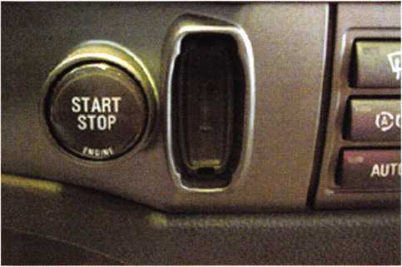

photo 6

2002 BMW 7451

The new BMW 745! is using a keyless ignition. (See photo­graph 6.) Like the Infiniti Q45, the transponder is located in the front of the remote key fob. Unlike the Q45, there is not ignition lock. Instead the fob is inserted into a small pocket on the dash, and an ignition button is depressed to start the engine.

Needless to say, these are just a few of the changes that have hit our trade over the last year. The TCL-i and SDD multi-manufacturer transponder key programming tools are currently the rage. Lockmasters is working with these tools and will be reviewing them in a future article.

For more information on transponders, current automotive locksmith trends and tools and PUREAuto Weekends, con­tact Lockmasters at (800) 654-0637 or visit our website at [www.pureauto.com](http://www.pureauto.com).

Captions

1. VW/Audi have gone from a 4-digit to a 7-digit PIN or LOGIN Code.
2. The Q45 is featured as “keyless” car, using a remote key fob to control opening and starting the vehicle.
3. The “keyless” car is proven a hoax, as we found that the standard blue cover Infiniti key can be pro­grammed to operate this vehicle.
4. The new G35 has a separate PIN number for every vehicle.
5. Starting in 2001, Toyota moved to a new ECU that allows key programming using a diagnostic tool and new onboard programming procedures.
6. The BMW 745! employees a true “keyless” ignition. D

Punctuality is a virtue,  
especially when you’re an  
ALOA member! All members  
who send in their dues

by Dec. 31. 2002  
will be eligible to win

in ITL950 Key Machine )e given away Jan, 2003

fejALOAk.

Keynotes • October 2002

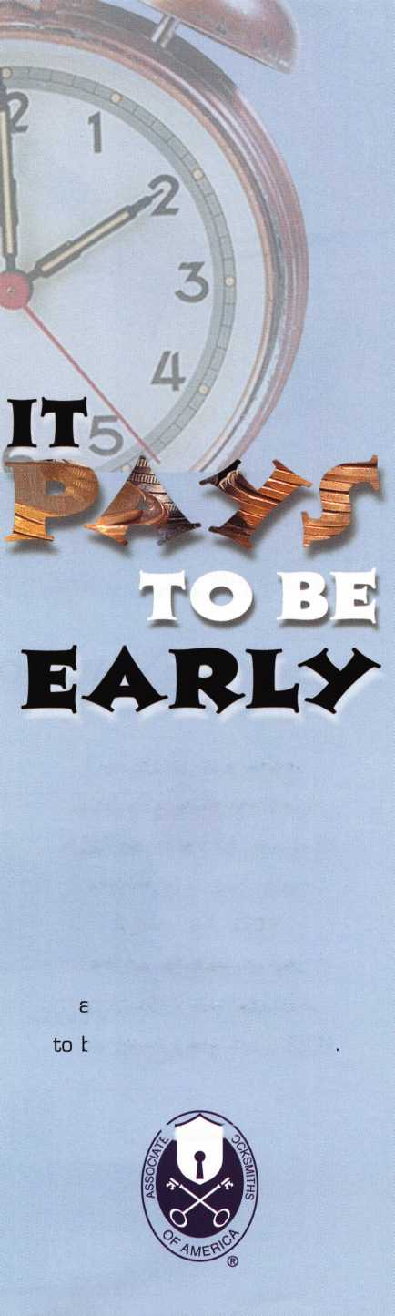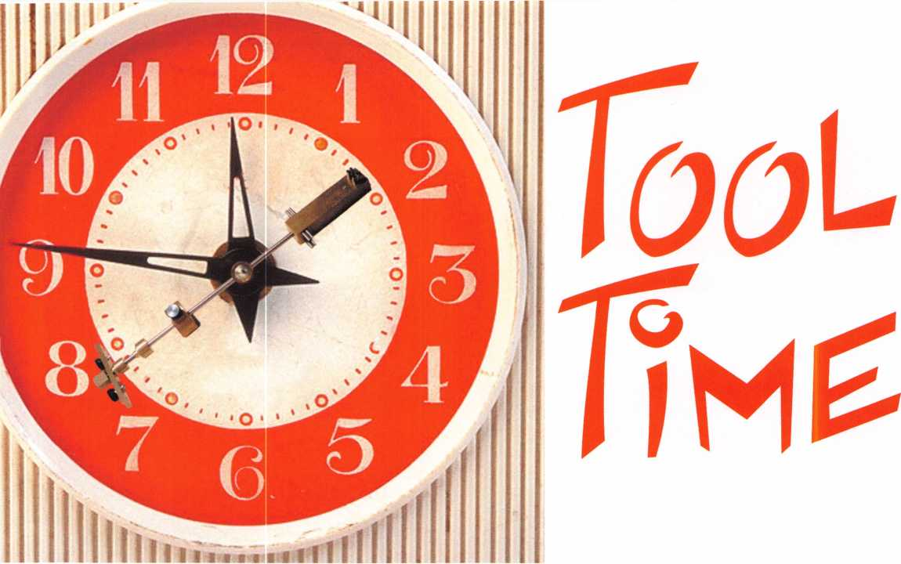

New Tools

from the ALOA Show

By Greg Perry, CML, CPS

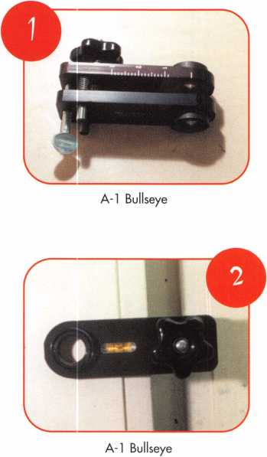

A trip to Chicago and the ALOA convention revealed  
lots of new tools and products. Being a tool fanatic, I  
ordered several and borrowed a couple to be able to  
show them to you. I used each tool in the field or on  
demonstration mounts to give a fair evaluation of  
them. Like most of you, I glanced at the instructions  
and set them aside for reading after things went wrong.  
To be fair, I did read the instructions after using the  
tools the first time. Most of us never read the instruc-  
tions first, so I wanted to put each tool to a “real  
world” test. Although I may be a little critical of some  
of the tools, each has enough value to be purchased if  
you have a need or can generate more revenue with  
them. My critical comments are meant to stimulate an  
even better product. Even more fairness: I’ll review  
them in alphabetical order by manufacturer.

First up is the new Bullseye cabinet lock installation jig  
from Ai seen in photos i and 2. Suggested dealer price  
is $85. It is advertised as assisting the installer with  
four different cross bores: 3/4”, 7/8”, 1 1/8”, and 1 1/4”. It

**8**

Keynotes • October 2002

has a clamping  
range of 7/16” to 1  
1/4”. We used it  
to install a couple  
of Olympus  
100DR cabinet  
door locks with  
7/8” cross bores.

Unfortunately,  
my customer has  
a no camera poli-  
cy, so I took a  
couple of pic-  
tures on my  
garage cabinets.

The jig looks  
similar to an old  
style Kwikset  
boring jig, only  
smaller with one  
hole. It worked as

designed, but I would like to offer a few suggestions.  
First, I wondered how it would accommodate four  
different hole sizes as advertised. They offer an  
optional 3/4” insert or you may bore the hole 7/8,”  
which is 1/8” oversize. There is no 1 1/8” insert, so you  
must overbore the hole to 1 1/4”. Adding the 3/4”  
insert with the jig would be nice. Second, the backset  
has to be calculated and there is no provision, other  
than a tape measure across the top for setting or  
maintaining it. The addition of a sliding or threaded  
stop would allow for a consistent backset. This would  
be very useful if you are installing locks on multiple  
cabinets. Lastly, I have run into lots of drawers con-  
structed of two layers of 3/4” material. Limiting the jig  
to only 1 1/4” prevents us from using it for these thick  
drawer fronts. Also, a cheat sheet or gauge would be  
nice for assisting with the math for proper placement  
of the jig. Would I buy the jig? I did and we will use  
it when we have multiple installs of cabinet locks. If  
they made a few modifications, each of our trucks  
would have one.

Next up are three products from Ken Doyle of Advanced Safe and Vault in San Francisco. The GF Blunder tool and the DUDAD were designed by Gerry Forder of Australia. The Blunder tool seen in photo 3 is a specialized tool for drilling into the lock case of a safe lock after the hole has been drilled to the lock case. Dealer price is $32. It comes with a flat- sharpened bit and a holder. The holder is a high quali­

ty drill stop. Unlike most drill stop collars that  
attempt to use a setscrew to grab the flutes of a drill  
bit, the Blunder tool bit has a flat on the shank like  
that used on hole saw guide bits. This allows the bit  
to be held more firmly and not slip for better accura-  
cy The great part of this tool is the ability to use it  
freehand or without a drill rig. The other flat end bits  
and end mills Fve used were best used in a fixed drill  
rig; this tool has already found a place in my safe  
drilling tool kit. The only recommendation I might  
have for this tool is to add a longer bit for thicker  
doors and a spare standard bit with the tool.

The DUDAD is seen  
photos 4 to 7. It’s name  
DUDAD is short for  
Down Under Dial Assist  
Device, and it sells for  
$49. It is used when the  
dial spindle has been  
knocked off and a dial  
needs to be reattached.

Fve found dials knocked  
off by burglars, but Fve  
also broken the spindle  
flush with the door myself  
while attempting to  
remove the dial. In the  
past, Fve used a Dremel  
tool with a cutoff wheel  
to create a slot and then  
used a screwdriver to turn  
the spindle. This tool is a  
much better solution. The  
idea is to gently tap the  
drill guide around the  
spindle, drill it, remove it,  
and finally tap the other  
tool into the drilled hole  
to provide a spindle  
extension. This will allow  
you to attach an emer-  
gency dial or a pulled dial  
onto the extension and  
dial the safe open. First  
problem I had was the  
door I selected to try it

on had a 1/2” spindle hole and the DUDAD requires a  
7/16” spindle hole. If I read the instructions first and  
measured the hole I would have used a different door  
for trying the tool. To compensate, I used some elec-

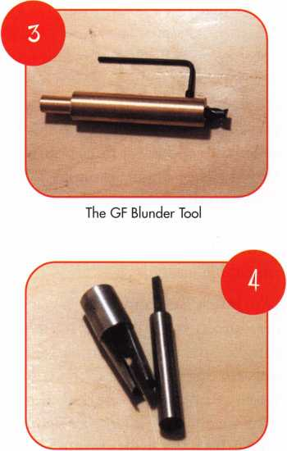

DUDAD

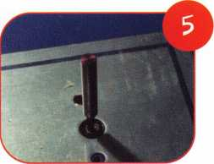

The DUDAD is attached to a  
broken spindle. The drill bit is  
drilling down the center of  
the spindle

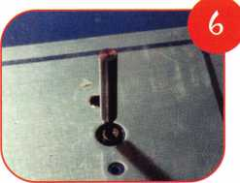

The spindle extension is tapped into the newly-drilled hole

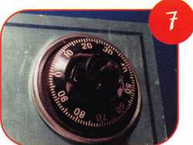

An emergency dial is  
attached to the extension and  
the dial ring is replaced

Keynotes • October 2002

trical tape  
around the tool  
before tapping  
it into the hole.  
This worked,  
but I would like  
to see a 1/2” ver-  
sion, or perhaps  
an adapter for  
larger spindle  
holes could be  
provided? Again,  
this tool is now  
packed away in  
my toolbox.

Wheel Maps are  
seen in photo 8  
at $26. Ken  
Doyle first

introduced these

at the SAVTA show in Reno, but I think they’re

worth mentioning here. The idea is not new, but they  
are a nice addition if you scope change keyholes. Ken  
has provided small laminated cards about the size of a  
business card with maps of safe wheels, so as you  
scope the hole, you know how far to get to a hub or  
gate of the wheel. They’re not expensive, and can  
save a little time on the job.

Major Manufacturing has introduced a couple of  
Door Totes. They sent me a couple of prototypes to  
try. If you hang or move doors, they might be of inter-  
est to you. The first Door tote model DT-200 is seen  
in photo 9; it’s more of a hand truck with a little  
extra. It has a suggested dealer price of $132.95. The  
handle allows you to lay the door down in the cradles  
parallel to the ground for installing hinges, or maybe  
working on the lock area. I removed my garage door  
to get a feel of how it moves doors. But before I  
could move the door, the deadbolt or middle hinge  
needed to be removed. I would like to see the upper  
cradle be adjustable and the handle a little longer to  
compensate for this. The unit held the door nicely  
and did not feel uncomfortable, although the addition  
of a clamp assembly that would not allow the door to  
rock when working would be a welcome addition. I  
used a rubber auto door wedge to secure the door as  
we removed the hinges for practice. If you have a new  
door or a door without locks and are moving it, this  
tool would be a nice addition. The other Door Tote  
model DT-100 is seen in photo 10 from Major is for

shops that move a lot of doors. The dealer price is  
$91.50. It is simply a two-wheel cradle. I moved my  
door around the driveway and found it to be useful,  
but not a tool we would purchase. We simply don’t  
sell enough doors to justify the expense or have the  
extra space for a tool we wouldn’t use very often. The  
other tote is one we might purchase. I spoke with Bill  
DeForrest of Major Manufacturing, who indicated  
these are the first two models they will be manufac-  
turing. Plans are for some different models that will  
be produced at a future date, and will include the  
adjustable cradle.

Northwest Safe and Vault has a special hole saw seen  
in photo 11 for drilling into the motor through the  
spindle hole of a Sargent and Greenleaf 6120 lock. It  
sells for $25. The idea is to avoid the hardplate of a  
safe by drilling into the lock through the spindle hole.  
This special .440 diameter hole saw is perfect. It goes  
down the hole, drills through the lock case, then final-  
ly into the motor. With care, you slowly remove the  
windings around the motor. Once they are removed,  
the armature can be seen in photo 12. To retract the  
bolt, it’s turned clockwise when looking at the bolt. If  
everything goes as planned, the safe is unlocked.

Total time to open this Hayman safe was about 30  
minutes. The next one

will go faster. This  
one job more than  
paid for the saw.

For automotive lock-  
smiths, I picked up a  
Strattec tool — the 8  
cut Ford lock assem-  
bly tool part number  
381944 seen in pho-  
tos 13 to 15 and sells  
for $7.50. This tool is  
a handy little device  
for assembling the  
ignition lock of the  
2002 Focus and  
some other model  
vehicles. Strattec was  
allowing attendees to  
assemble a lock at  
the show and then  
giving us the lock. I

would have preferred the tool, but they told me I had  
to buy it. Once the plug is keyed, the face caps is ori-

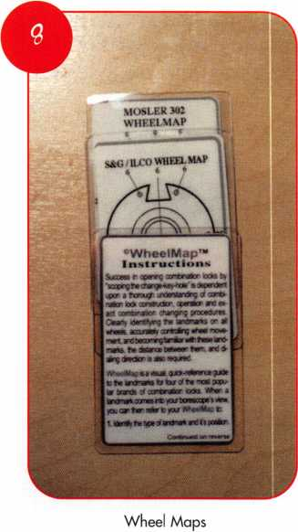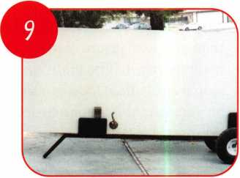

Door Dolly with handle

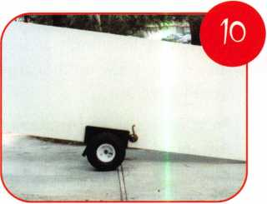

Door Cradle

Keynotes • October 2002

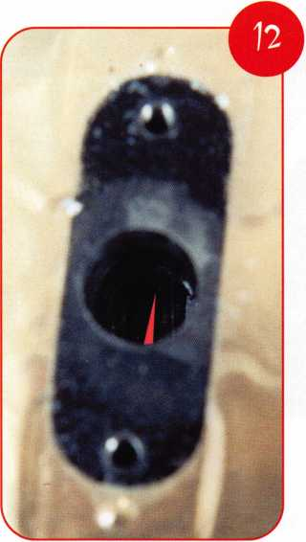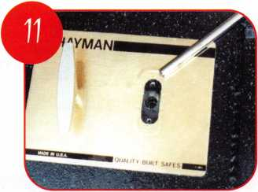

Special Hole Saw

ented to the cor-  
rect location.

The face cap has  
a tab that aligns  
with a cut-out on  
the plug. The  
tool is then  
placed over the  
back of the lock  
housing and the  
plug is pushed  
down into the  
housing. The  
tool is needed to  
push the wafers  
into the plug  
allowing it to go  
into the housing.

This could be  
done by hand,  
but the tool  
makes it much  
easier. Once the  
plug is inserted  
into the housing,  
it is turned to  
the locked posi-  
tion and the key  
should be tested  
for proper opera-  
tion. If the lock  
needs to be disas-

sembled, the forks of  
the tool are used to

push the wafers into the plug, allowing it to turn. You could also pick the lock, but again the tool is much faster. It works a little like shimming a pin tumbler cylinder only much faster. Once the tool is seated against the back of the housing, the tip of the key is

View of the drilled spindle hole.  
The motor armature can be seen  
at the bottom of the hole.

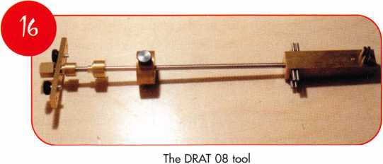

inserted and the  
plug is turned to  
the location  
where it was  
originally insert-  
ed and it will pull  
out of the hous-  
ing. If your shop  
does automotive

service work,  
you need this  
tool.

I want to add  
one more tool  
to the collec-  
tion, the  
DRAT-08. It is  
the dial ring  
alignment tool  
manufactured  
by Locks  
Unlimited seen  
in photo 16. It  
is designed to  
work with both  
the Mas-  
Hamilton X-08  
and the X-09. I  
will use and  
review it in a  
latter article  
when the X-09  
is available.

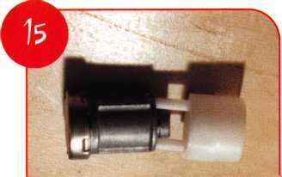

*w*

Used this direction the tool  
will allow disassembly

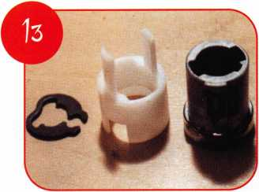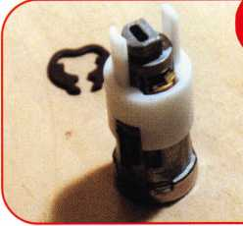

Strattec tool is the white plastic piece

The tool is used to install the keyed-up  
plus into the housing

Where do you find these tools? A-i, Major Manufacturing, and Strattec tools are available from most major lock distributors. The A-i Bullseye jig can be seen at, [www.demandai.com](http://www.demandai.com) or (804) 359-9003, the Major Manufacturing Door Totes can be seen at [www.majormfg.com](http://www.majormfg.com) or (714) 772-5202, and Strattec’s number is (414) 247-3333. The GF Blunder tool, the DUDAD and the Wheel maps are available from Advanced Safe and Vault who can be reached at [www.advancedsafe.com](http://www.advancedsafe.com) or (415) 282-6782. Northwest Safe and Vault is found at [www.safe-tech.com](http://www.safe-tech.com) or (877) 241-6978. The DRAT tool from Locks Unlimited (703) 960-6413 is available from Timemaster Inc. [www.time-master.com](http://www.time-master.com) or (888) 798-8465 or MBA [www.mbausa.com](http://www.mbausa.com) or (888) 622-5495. Q

Keynotes • October 2002

^*°n ^

Lock picks are among the most basic locksmith  
specific tools. While others will use them (or at  
least try) for opening locks, lock picks them-  
selves are primarily for our profession. Quite a  
few different companies  
have lock picks in their

product line, and most  
of them are pretty sim-  
ilar in material and  
configuration. It seems  
that when a new com-  
pany decides to start  
manufacturing lock  
picks, the thinking  
behind doing it is more  
imitation than innova-  
tion. Well, there is a  
new player in the  
arena. The lock picks  
and sets from Peterson  
Manufacturing seem to  
indicate a rethinking

By Sal Dulcamaro, CML

from the ground up. From the materials that make them to the configuration and further, to the way they are arranged and packaged,

I sense some well thought out innovations.

I’m going to start with the less important inno­vations first, and then explain some of the more significant ones later in the article. Not neces­sarily critical, but worth noting, the packaging of Peterson picks has some interesting innova­tions. Since they are not the first makers of lock picks, it is wisely presumed that many potential locksmith buyers already have pick sets and that not everyone who wants to buy picks wants (or needs) to buy another carry case. You have a number of purchasing options. You can buy a number of pick sets that include a quality leather carrying case, or you can buy some assortments in a plastic tube that you can put in a case you already own. If you want you can buy a carrying case separately and assemble your own assortment of picks, you can do that too.

**22**

Keynotes • October 2002

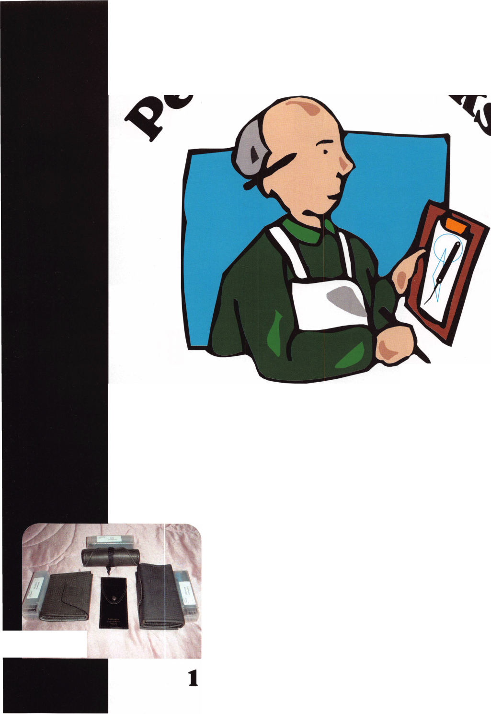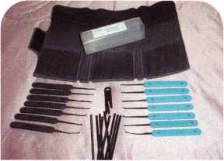

The four sets that  
include leather-carry-  
ing cases are shown in  
photo i. At the top is  
the Journeyman’s Roll  
Set. On the left is the  
Professionals Bi-fold  
Set, and on the right,  
you can see the  
Master’s Tri-Fold Set.

In the middle is the  
smallest (basic) set  
called the Slim

Pickings Set. In the  
photo, you may notice  
that the three larger  
sets have a plastic tube  
accompanying the  
carry case. At the cur-  
rent time, the picks are  
not always preloaded in  
the leather cases, since  
the cases are also sold  
without picks. These  
particular pick sets are  
not available, however,  
without the case.

There are other assort-  
ments in tubes that do  
not include leather  
cases that I will refer  
to later.

The Master’s Tri-Fold  
Set is shown in photo-  
graph 2, with all the

Jf picks spread out. The

m carrying case uses a

Velcro strip closure and only comes in black. I will go into

actual pick shape and configuration later, but I will just give the names of the picks for now. Peterson picks come in seven basic configurations: Double Rake, Triple Rake, Long Ripple, Hook, Peterson Gem, Diamond Pick and Peterson Reach. Picks are available with “no handle,” and also with black rubber or blue plastic handles. In the Master’s set, you get all seven picks in both rubber and plastic handle ver­sions. One broken key extractor is included and it has “no handle.” That just means there is no plastic or rubber cover­ing over the existing metal handle. There are no “no handle” picks in the Master’s set, but there are some in other Peterson pick sets. In the photo, between the sets of rubber and plastic handle picks, you will see the Peterson Bending Tool and nine Tension Tool Blanks. Those are some of the

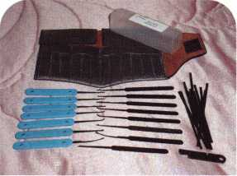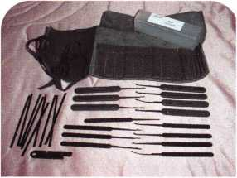

From the materials, the  
configuration and the  
way they are arranged  
and packaged,  
Peterson offers some  
well-thought innovations.

other innovations I referred to earlier. I will explain them later. I’m saving the best stuff for last.

You will find the Journeyman’s Roll Set spread out in photo­graph 3. The set uses a soft leather case that you can roll up and tie shut. The roll case is available in black or brown leather. It includes all seven styles of picks in rubber handle and plain (“no handle”) versions. An eighth “no handle” tool is the extractor. Like the Master’s kit, it includes nine Tension Tool Blanks and the Peterson Bending Tool.

Photograph 4 shows the Professional’s Bi-fold Set. The case is available in both black and brown leather. The contents are similar to the Journeyman’s Roll Set, except that blue plastic handles are used in place of the black rubber handles from the other set. Otherwise, the contents are the same.

The smallest set with a leather carrying case is the Slim Pickings Set found in photograph 5. The set has one of each style tool, with three plastic handles and four “no handle” picks. The fifth “no handle” tool is the extractor. There are three Tension Tool Blanks and a Peterson Bending Tool.

Photograph 5 shows the “The Basics” in a tube pick set. This set does not include a leather case and all the tools come “no handle” style. All of the seven pick styles and an extractor are included. You also get three Tension Tool Blanks and a Peterson Bending Tool. The set comes in a compact one-half inch by one-half inch square plastic tube.

Just Picks

I mentioned earlier that you can buy “just picks” without a carrying case. In addition to the welcomed ability to buy individual replacement picks, in the “Just Picks” product offering, you can order pre-designed assortments of lock picks packed in a plastic tube. The “Just Picks” Assortment includes all seven styles of picks with plastic handles and four more with rubber handles, plus an extractor (no han­dle). The “Just Picks” Rubber includes all seven picks with rubber handles and an extractor. “Just Picks” Plastic also has all seven picks but with plastic handles and includes an extractor. All three assortments come in a reusable plastic tube. If you purchase a case separately, you can use these as part of a create your own pick set.

Keynotes • October 2002

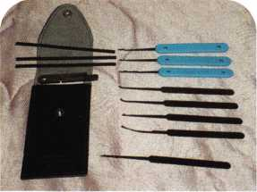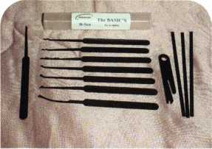

:T:;

***mmm***

***mmk m***

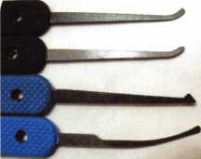

You can also order any of the seven pick configurations individually or in the specific quantities that you prefer in rubber, plastic or “no handle” varieties. I gave you the names earlier; now I’ll show you what they look like.

From the top to bottom in photograph 7, they are Double Rake, Triple Rake and Long Ripple. These are multi-point contact picks. Photograph 8 shows the single point con­tact picks. From top to bottom, they are Peterson Gem, Hook, Diamond Pick, and Peterson Reach. Some of the shape configurations are like others you’ve probably seen, but a few are unique. The two middle picks (Hook and Diamond Pick) are fairly standard in appearance, but the two on top and bottom are hybrids. The Peterson Gem adds a diamond shaped tip to the end of the standard

hook to provide greater reach. It is  
designed to contact a hidden or awkward  
pin where a standard pick won’t reach.

The Peterson Reach carries the same princi-  
ple a step further for even more awkward  
spots or keyways.

Though some of the pick designs bear a  
physical resemblance to others you’ve seen,  
££ there are some really important differences.

The pick contact surface is one of those  
differences. Peterson picks are “broken in.”  
Think of it in relation to a pair of shoes.  
When you try a pair of shoes on new, they  
tend to be stiff and uncomfortable. After  
you’ve walked a few miles (uncomfortably)  
in them, they start to feel right and they are  
then “broken in.” Many picks have rough or

sharp surfaces and don’t work smoothly or  
comfortably in the keyway of a lock in con-  
tact with the tumblers. They use a vibratory  
polish procedure on the picks to smooth out  
the rough edges and give the picks a

JW smoother “broken in” feel when you use

them. The pick contact surfaces are the same  
for the different handle style picks. The base  
picks are the same, just the handle style varies  
between the rubber handle, plastic handle  
and “no handle” picks.

And now to the most important innovation:

“Peterson Steel.” I won’t attempt to describe  
the metallurgical content, but it is both rigid  
and flexible. I know it sounds contradictory,  
but those characteristics in a pick are not  
mutually exclusive regardless of your experi-

M\ ence ot^er brands of picks. Apparently  
^ specialty steel plus a precision controlled heat

treatment process gives “Peterson Steel” the proper combination of hardness and flexibility to make a picking tool more effective. It has greater flexibili­ty, so that a pick can bend and be straightened with less chance of breakage than the more brittle steel used for most other picks. At the same time, the added flexibility does not feel soft or weak when trying to lift and maneuver tumblers within a keyway. It equals or betters the stiffness of the more brittle tools.

“U-BEND-IT” Tension Tools

While flexibility is not necessarily the first thing you consid­er when thinking about the picks themselves, it is very sig­nificant regarding another very important innovation of Peterson picking tools. That is the new concept tension (turning) tools. In the earlier photos and descriptions, you may have been wondering where the turning tools were in

Keynotes • October 2002

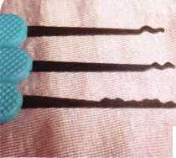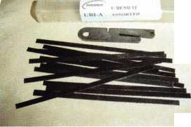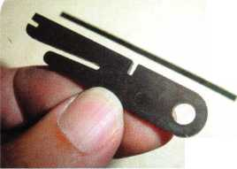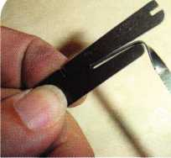

11

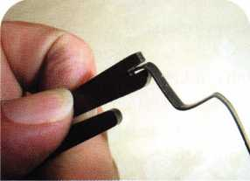

12

the Peterson pick sets.  
All shown were a  
bunch of narrow flat  
steel strips. There were  
no angles bent to allow  
you to apply turning  
pressure when you  
attempt to pick a lock.  
Well, there were no  
bends, because you  
bend it. That also just  
happens to be what  
they are called (though  
spelled differently): “U-  
BEND-IT.”

Besides the assort-  
ments of “Just Picks,”  
you can also order just  
tension tool blanks.  
One such assortment is  
shown in photograph  
9. This set includes the  
Peterson Bending Tool,  
but if you  
already have

the tool, you

can reorder ten-  
sion tool blanks without the tool. Photograph 10  
shows a close-up view of the Peterson Bending Tool.

There is a bit of an optical illusion because the ten-  
sion tool blank is on the table below (a few inches  
lower) and the camera lens made the tool look longer  
than the blank. The length comparison is to propor-  
tion in photo 9.

Just a few of the possible bends you can make are  
illustrated in photographs 11 and 12. The tool is set  
up to make sharp or rounded corners. With the aid  
of a pair of pliers, you can also make twists to change  
the direction of your handle or modify the strength  
of turning pressure for your tool. You can custom  
shape a turning tool for an awkward lock configura-  
tion or a deep concave knob where all your “stan-  
dard” tools won’t measure up. The tool alone won’t  
do the job for you. The “Peterson Steel” is the key.

If you tried to bend one of your existing turning  
tools or just some generic spring steel, the brittleness  
of the metal would typically cause breakage before  
you could create the shape you were looking for. The  
tension tool blanks are a bit wide and work great for  
auto locks with dust shutters, but might require a bit  
of modification to make them narrower for really  
tight commercial keyways. Narrower version blanks  
will be available very soon. You can check the web-

site for availability. The site is very easy to navigate and shows pictures and descriptions of all the products.

Ken Persson, the creator of these new concept pick sets is also responsible for the Peterson Pro tubular lock pick. He has a track record for innovation and you can always expect a unique new twist on an old concept when it gets processed through his mind. I always look forward to new projects on his agenda. I await a couple of projects that I’m not privy to disclose at this time, but I will when he has them ready to run. Just a hint for one of the projects: You didn’t see any new style extractors in the kits, did you?

One final note: Lock picking is accomplished by skilled technicians, but made more efficient with quality tools.

The tools in unskilled hands will perform no better than any other brand tools. If you have the skills, you can often succeed with mediocre or low quality tools. Having good tools just makes a job a lot smoother. For more information on the Peterson Picks, you can find them online at: [www.peterson-international.com](http://www.peterson-international.com), or contact by e-mail at the following: [kenpersson@aol.com](mailto:kenpersson@aol.com) .

Telephone: 585/264-1199. FAX: 585/586-0425. Q

3232

Professional  
Business  
Products

Associate Member of ALOA

ALOA 2002 Convention Exhibitor  
ALOA's Preferred Vendor Of Business Forms  
And Promotional Items...

We Will Save You Money

Locksmith Business Forms with ALOA Logo  
Custom Forms • Labels • Stationery  
Promotional Items...

We Do It All

Call for samples, quotes or with any questions

1**-**800**-**355-6322

or visit us at

[www.professionalbusinessproducts.com](http://www.professionalbusinessproducts.com)  
e-mail: [sales@professionalbusinessproducts.com](mailto:sales@professionalbusinessproducts.com)



Keynotes • October 2002

Inside Electronic Lockers

with Master’s Digilock

David Thielen CML

The Digilock is a battery-operated electronic  
locker lock made by Master Lock Company.  
This lock utilizes a button key that complies  
with the ADA requirements, and enables  
you to provide security for those who are  
visually or physically impaired.

There are three basic models available. The  
2630 works similar to the Master 1630/ 1631.  
This lock would be used on lockers with  
handles and automatic locking rods. The  
locking bolt moves horizontally, and is auto-  
matically relocked after four seconds. The  
2654 works similar to the Master 1654/1655. This lock  
would be used on box lockers and single-point latch  
type lockers. The locking bolt is a spring latch that  
moves horizontally and is automatically relocked. The  
2670 works similar to the 1670/1671. This lock could  
be used on most all lockers. The bolt moves horizon-  
tally but does not automatically relock. The 2670 stays  
unlocked indefinitely until the button key is used to  
lock it again.

All three models can be used in a right or left hand  
configuration, and require door thickness of .030 - .125  
inches, which is typical of most lockers. These locks  
will fit most existing lockers, but be sure to check  
before placing an order, as I have found some brands  
of lockers where they would not fit. On some lockers  
a minor adjustment to the mounting holes or bolt  
receiving cavity may be necessary for a retrofit  
condition.

The Digilock operates on two 9 Volt batteries, which  
are included, and have an average life of three to seven  
years. When the batteries become low, the lock emits



Keynotes • October 2002

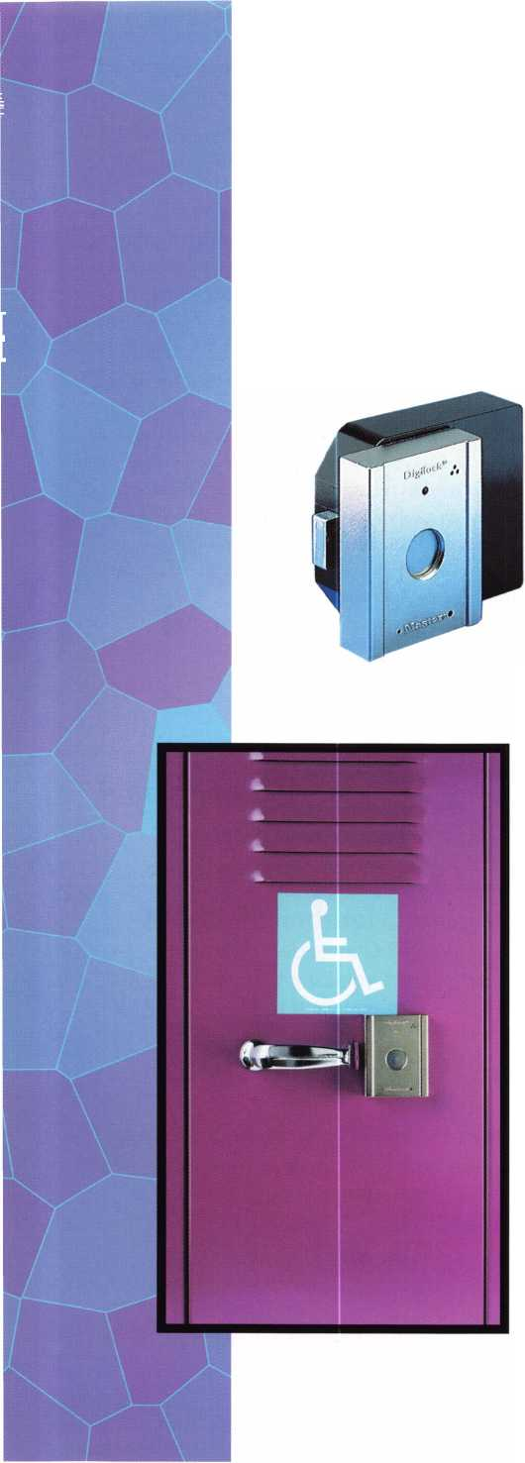

a triple beep each time it is opened, indicating the  
need to replace the batteries. If the batteries go  
totally dead, an external power jumper unit is avail-  
able to power up the unit to unlock it and replace  
the batteries.

The Digilock comes with a two-year manufacturer’s  
warranty. All three models of the Digilock are pro-  
grammed and operated the same, so we will take a  
closer look at the Model 2630.

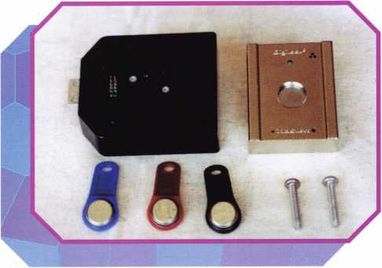

Photo 1 shows the complete lock with three differ-  
ent button keys, the inside housing (black), the out-  
side housing (chrome), and two mounting screws.

The 2630, as well as the other models are made of all  
metal construction. Photo 2 shows the 2630 installed  
on a locker with a handle, and automatic locking rod.

Photo 3 shows the inside of the locker. The installation on this locker  
is extremely simple. First, remove the standard Master 1670 lock, than  
snap together the connector, mating the inside housing with the out-  
side housing. Next, install the two through-bolts and installation is  
complete. No modification to the locker or locking rod is required.  
Photo 4 shows the backside of the outside housing with the snap-  
together connector. Photo 5 shows the inside housing with the snap-  
together connector. You cannot install the snap-together connector the  
wrong way, because the unit is not handed.

photo 1

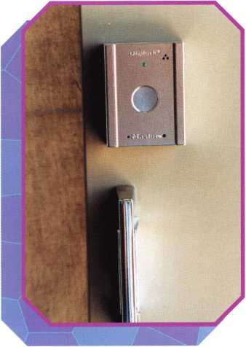

photo 2

Let’s take a look at how to program this unit. There are  
three different button keys in Photo 13. The “Manager”  
key is black, the “Programming” key is red, and the  
“User” key is blue. Each button key is unique and carries  
an embedded serial number. A User key may be regis-  
tered to more than one lock. If a User key or Manager  
key is lost, a new replacement key can be registered,

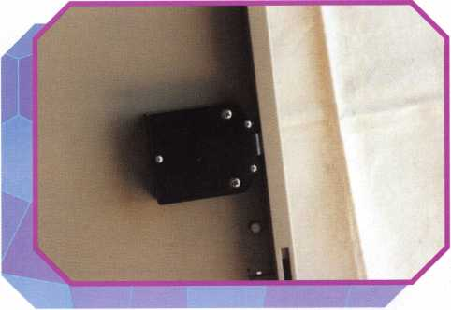

Photo 6 shows the outside housing. The round, center portion is  
where you touch the button key to lock or unlock the Digilock.

The LED light is an indicator for the hearing impaired that the  
door can be opened. There is also an audio indicator for the visually  
impaired. When unlocked, the 2630 emits five beeps to indicate it is  
unlocked. If the Digilock emits three beeps, this is an indication that  
the batteries are low and should be replaced. Photo 7 is the lock hous-

ing with cover installed. Photo 8 shows the cover removed

by removing three small screws. Two 9-Volt batteries  
and a solenoid can be seen. Photo 9 shows the batteries  
removed. Photo 10 shows the bolt retracted. Photo 11 is  
an end view of the spring-loaded bolt. Photo 12 shows  
the internal circuitry of the lock. There is no reason to  
take this apart (other than curiosity), as there are no  
components that can be serviced.

photo 3

Keynotes • October 2002

**2**

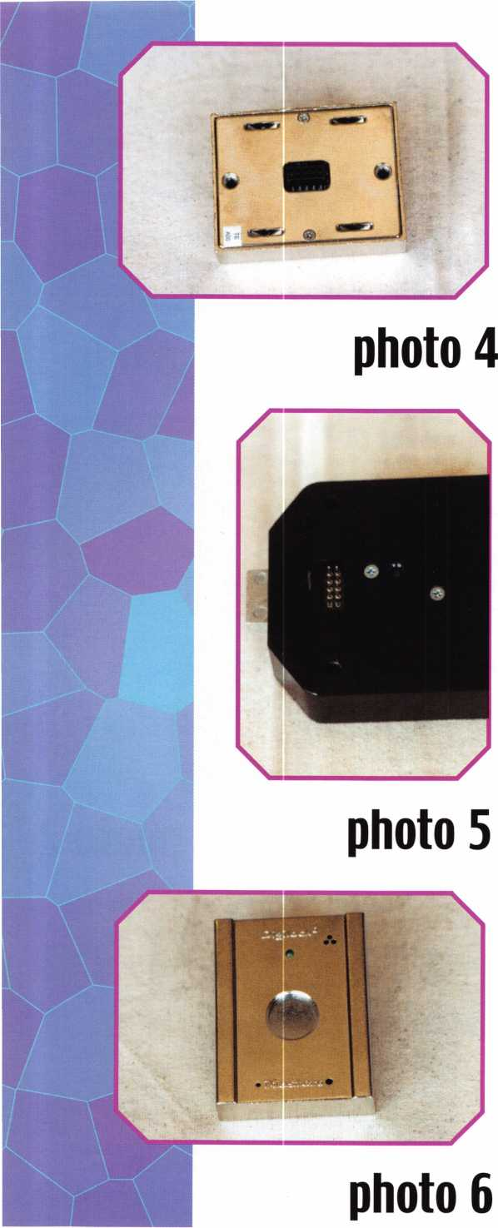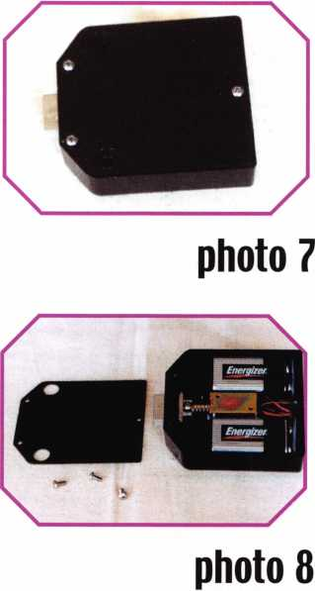

thus deleting the old key. If the  
Programming key is lost, you must  
contact the factory

To register a User button key, first touch  
the Programming key (red) to the lock  
(the green light will come on). Next,  
touch a User key (blue) to the lock (the  
green light will turn off, and you will hear  
a triple beep, indicating a successful regis-  
tration of the User key). If a User key  
(blue) is lost or stolen, obtain a new one  
and repeat this procedure. When the new  
User key (blue) is registered, the old one  
will no longer work. You may register the  
same User key (blue) to multiple locks if  
you wish.

To register a Manager button key (black),  
touch the Programming key (red) to the  
lock (the green light will come on). Touch  
the Manager key (black) to the lock (a sin-



Keynotes • October 2002

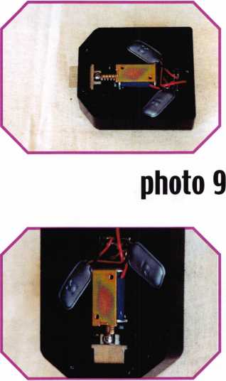

photo 10

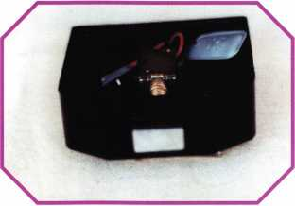

photo 11

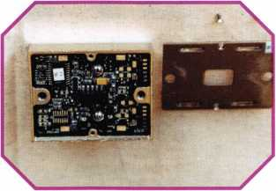

photo 12

gle flash of the light and a single beep will indicate a successful reg­istration of a Manager key). You may program up to five Manager button keys (black) to a single lock.

If you are registering less than five Manager button keys (black), touch the Programming key (red) to the lock to terminate the programming. If a Manager key (black) is lost or stolen, obtain a new one, and repeat this procedure. When the new Manager key (black) is registered, the old one will no longer work.

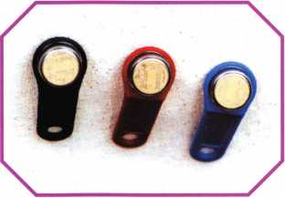

photo 13

The Digilock by Master Lock looks to be versatile, easy to install, easy to program and carries a nice warranty. This is a unique product to offer to your customers who need locker security and ADA com­pliance. Typical users would be schools, health Clubs, Rec. Centers, Manufactures and Businesses with employee lockers. Q



Keynotes • October 2002



RING of a KING

|  |  |  |  |
| --- | --- | --- | --- |
| Name | Members | Name | Members |
|  | Recruited |  | Recruited |
| Kwok-kei Leung | 212 | Joseph P. Ferrero CML | 16 |
| Henry W. Raymond | 100 | Gary F. Teams CPL | 16 |
| Yuriko Yanai | 77 | Kenneth E. Kim CRL | 16 |
| Mary S. Ohmit CPL | 66 | Joseph W. Whitaker CPL | 16 |
| Charles C. Robertson CML | 65 | Michael E. Jordan Jr, CML | 16 |
| Jack Hobin CPL | 51 | Brian J. Reetz | 16 |
| Salvatore J. Dulcamaro CML | 40 | David M. Troiano | 16 |
| Myeong-Rae Cho | 38 | Robert C. Rodocker CPL | 15 |
| C. Allan Halverson | 37 | William J. McElheney CML | 15 |
| William Lee | 37 | Jon B. Griswold CML | 15 |
| Dana L. Barnum CML | 35 | Michael D. Robinson CRL | 15 |
| Barry K. Leas CRL | 35 | John A. Ilk CRL, CPS | 15 |
| Danny W. Rudd CPL | 32 | Russell P. Fuller CRL | 15 |
| Michael B. Groves 32 |  | Daniel L. Landry Jr | 15 |
| Larry A. Warnick CML | 31 | Steve L. Cothron | 15 |
| Jim Williams CRL | 31 | Leonard J. Passarello CPL | 14 |
| Jeanne G. Lodge CML | 30 | Ernest W. Wright | 14 |
| Eugene R. Altobella Sr | 30 | Paul M. Souber | 14 |
| John C. Elliott Jr, CML, CPS | 28 | James T. Brickler CRL | 14 |
| Robert D. DeWeese CML | 28 | Joseph C. Fuller CML, CMST | 13 |
| Lawrence F. Smith Jr, CML | 27 | Calvin G. Harris CML | 13 |
| James M. Watt CML, CPS | 27 | Peter Sarailian CRL | 13 |
| Anthony J. Ramunno CML, CPS | 26 | Frank D. Hartung CML | 13 |
| Marian M. Swann CRL | 26 | Rolando Bouza | 13 |
| Scott L. Henke CPL, CPS | 26 | Donald H. Shiles RL | 13 |
| Robert F. Carroll CPL | 26 | Richard C. Sievers | 13 |
| Jeffrey S. Nunberg CML, CMS | 26 | Eugene R. Altobella Jr | 13 |
| J. Thomas Hood CML | 26 | John W. Soderland CML, CMST | 12 |
| Robert H. Stafford CML | 25 | Raymond C. Lusk CML | 12 |
| Jerome L. Cohen CML | 23 | John F. Engel CRL | 12 |
| Peter K. Gauthier CPL, CPS | 23 | Eric F. Veal | 12 |
| Elvis D. Hammerschmidt CPL | 23 | Thomas J. Demont CML, AHC | 11 |
| Philip A. Rovenolt CPL | 23 | Basil W. Shannon CPL | 11 |
| Man-Soo Seo RL | 23 | William J. Wickward CML | 11 |
| Diana R. Barnum CRL | 22 | Timothy K. Chow | 11 |
| James J. Cawby CML, CPS | 22 | Dale L. Knowles CPL | 11 |
| John L. Shandy CML | 21 | James V. Hawley CRL | 11 |
| Robert W. Duman Sr, CML | 21 | Alvin N. Minor | 10 |
| John S. Dorsey CML, CPS | 19 | Gene Eldridge CPL | 10 |
| Keizo Takahashi CRL | 18 | Ronald P. Riggins CML | 10 |
| James E. Fowler Sr, CML | 18 | Lester S. Brodsky | 10 |
| David C. Harris CML | 18 | Larry L. Votaw CML | 10 |
| Takashi Kuwana CRL | 18 | Thomas R. Smith CPL | 10 |
| Peter R. Hall | 17 | Todd K. Ladwig CML, CPS | 10 |
| Thomas G. Vandersteen CML, CPS 17 | | William T. Straub CML | 10 |
| William P. Grant CRL | 17 | Richard T. Johnson CPL | 10 |
| James E. Gruber CRL | 17 | Robert M. Massard CRL,AHC | 10 |
| James L. Hancock CRL | 17 | Marian E. Sagar | 10 |
| Evelyn V. Wersonick CML, CPS | 16 | William T. Beranek | 10 |



How can I join the President's Club?

You can earn a membership in this prestigious club by recruiting  
just 10 new members for ALOA.

*Any ALOA member may participate.

What do I get?

When you recruit 10 members, you receive a handsome blue blazer with a President's Club crest. For each addi­tional five members you recruit, you receive a lapel pin with gold-filled numbers, indicating, your recruiting suc­cesses.

You also get the satisifaction of knowing that you are  
helping your association, helping your industry grow,  
and you are helping fellow locksmiths achieve success.

How do I get started?

Mail the form below to the ALOA office for a supply of  
applications (800) 532-ALOA or FAX (214) 827-1810.  
One President's Club credit is awarded for each new  
applicant. Credit is awarded only after the membership  
application is pproved. However, the credit will apply  
for the period in which the application is received.  
Failure to identify yourself as the sponsor on the applica-  
tion form at the time it is submitted to ALOA for process-  
ing will forfeit any credit.

Yes! I want to join the ALOA President's Club.

Please rush me applications so I can start earning credit toward membership in the club!

Name

Company

Address

City State Zip

Mail this form to ALOA • 3003 Live Oak • Dallas, Texas 75204-6186

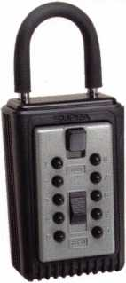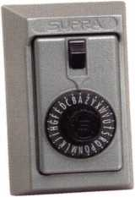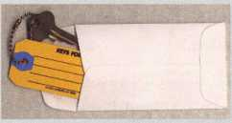

**products locksmith Professionals**

**\*$7.00 SHIPPING CHARGE ADDED PER ORDER** NY RESIDENTS ADD APPLICABLE SALES TAX

**SANZO SPECIALTIES, INC. BOX 68 ENDICOTT, NY 13760 TOLL FREE: 1-800-222-4041 FAX: 607-748-0507**

**COMBINATION KEY BOXES**

©SUPRA

**ALL METAL**

**PROFESSIONAL**

**SERIES LOCK BOXES**

Key Storage Lock Box

* ALL METAL Construction
* Great Economical Pricing
* Simple to set/ Simple to open
* 5 Year Warranty

Both models now have weather resistant ALL TITANIUM METAL CONSTRUCTION with metal back and buttons. Both models are also available with PUSH BUTTON COMBINA TION LOCKS that are easy to set & reset.

Stock # C3-PUSHBUTT0N

Removable KeyBox, DoorGuar rubber bumper protects surfaces

Stock #C3-DIAL  
Removable KeyBox  
DoorGuard rubber bumper protects surfaces

**DIAL**

1-4 36.95 EA. / 5-9 33.95  
10 or MORE 30.95 EA.

**PUSHBUTTON**

1-4 37.95 EA. / 5-9 34.95 EA.  
10 or MORE 31.95 EA.

Stock #S5-DIAL Surface Mount Unit

ShurLok has designed an all-metal key storage box that is the safest, most secure lock box on the market. Separate easy to set combinations open the shackle and key compartment — and the combinations can be changed in seconds. The ShurLok is so simple to use a child can open it, yet so versatile it will satisfy the Real Estate professional or anyone requiring key access in a lock box. Unique double combination allows all users access to key(s) while allowing only authorized users access to the shackle and will prevent lock box removal or theft.

No Home Should Be Without One The Surface-Mount S-5 Supra Lockbox is a product you can provide to any homeowner, easily priced to your customer in the $50.00 range installed (simple 4 screw installation). Carry one with you at all times to demonstrate - once shown it sells itself!!

**1 to 9 $19.95 ea.**

**10 or more $17.95 ea.**

*if color is not specified we ship blue*

Stock #SLK100R

Brick Red

Stock #S5-PUSHBUTT0N

Surface Mount Unit

Stock #SLK100  
Blue

**AD / ID KEY TAGS**

Specifically designed to identify the product you work with daily and promote your business with your custom Ad copy.

back side of tag with 4 lines for key identification

KEYS FOR

**Clear Plastic Protective Sleeves** Stock# PPS10

Protect your key tags with  
durable plastic sleeves

* 100 200 500 1000

11.50 19.95 42.00 68.50

e

**Key Tag Envelopes**

Stock # KTE3 Actual Size: 2'k" x 4W Added security and finishing touch when presenting keys to your customers

* 100 200 500 1000

10.50 17.00 37.50 65.00

**TO ORDER:** Choose QTY.,

ey Tags with Chains or  
ings, TAG COLOR and

Provide Imprint Copy  
(printed black only).

QUANTITIES

**FREE Printing of Your Ad Copy on bac**

ANDOVER LOCK & KEY SERVICE

3221 LAKESIDE HWY

ANDOVER MA 05242  
(508) 626-1111

Choose from Brass Plated Bead Chains or Chrome Plated Wire Rings

LAKEVIEW

LOCKSMITH

24 Hour Service . **(845) 556-LOCK**

1000

2000

3000

5000

**\*** KEY TAGS with CHAINS or RINGS 32.00 42.95 83.95 115.00

YOUR CHOICE OF CHAINS OR RINGS - IF NOT SPECIFIED WE SHIP CHAINS

195.00 269.00 395.00

Key Tags Only (no chains or rings) - Deduct 10% from above prices

National Logos - No Charge / Custom Logos - Add $25.00 and supply clean B & W artwork

**Set your own combination**

The combination can be changed in seconds —  
without special tools or disassembly. Changing  
the shackle combination also automatically changes  
the combination for the sliding key storage door.

**10,000**

button **^Combinations**

**Possible!**

/^X Change

|  |  |
| --- | --- |
|  | 'f— |
| Il(iiii) | i |
| (1 | .1 \Q |

Changing the

for the shackle  
only takes a few seconds  
I) with a simple turn  
of the change button.

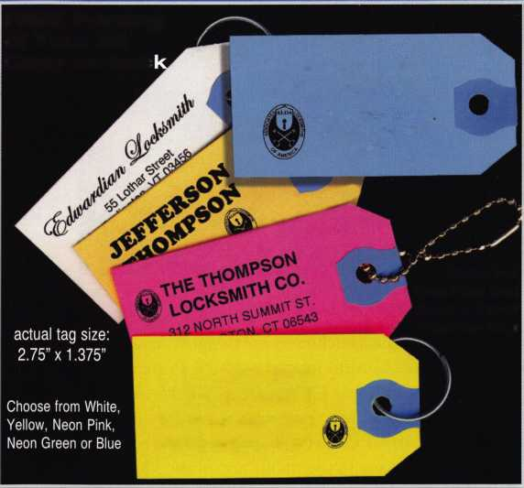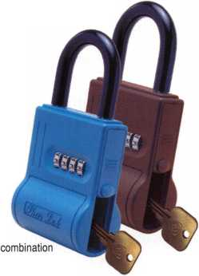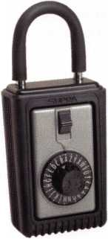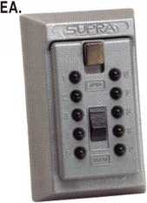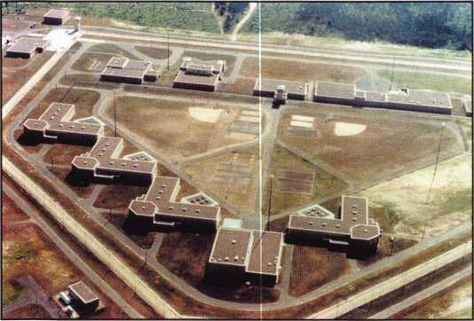

Jackson Correctional Facility

Black River Falls, Wisconsin

In August of 1999, I finally achieved my designation as CML (Certified Master Locksmith) from the ALOA Proficiency Registration Program. It was a proud day in my life. When someone asks whether or not the public knows (or cares) what a CML, CRL or CPL is, they have good reason to ask. The fact is that not many in the public are aware. However, some not only know, but also have a sincere appreciation for those designations and what they represent. And, those kind of people are most often great customers!

Less than two months after receiving my CML designation, the Jackson Correctional Facility, a Wisconsin State Medium Security Prison, contacted me and requested that I come to their facility. I quoted my hourly fee plus travel charges, and they agreed and gave me a purchase order. The distance to the Jackson County Correctional Facility is approximately 58 miles.

The officials at the facility needed an “expert opinion and evaluation” of:

* Their key duplication equipment
* The accuracy of their key machines
* Their master key system, and
* The locks and cylinders they were using.

Arriving at 8 a.m., I went through the security check routine that is common at any jail or prison, emptying my pockets and toolbox for inventory. I then met with the officials that requested my services, and we proceeded to start on the task before us.

The facility was using two Ilco duplicators. The first was quite old, but appeared to be in good condition. The second one was about 8 to 10 years old. Both good machines, and were operating as Ilco designed. I duplicated a sample key that I cut onto an OEM blank, both of which I had brought with me. Then I cut one of their keys onto one of their blanks. Both were found to be within a half of a thousandth of an inch, very adequate, to say the least.

Yile had designed their master key system. It was a good

The Time I Spent in Prison:

It changed my life,

and it can change yours too

By John Dorsey CML, CPS

multi-level system, designed when the facility was on the drawing board. Like the key duplicators, the master key sys­tem was both appropriate and adequate.

The facility’s locks were Grade I Yale hardware, with con­ventional Yale six-pin cylinders. By “conventional” I mean in as much as they were standard, not mogul cylinders. The choice of keyways was in the “T” sectionals, so unauthorized duplications were not a serious concern.

Many locksmiths, and, even more so, the public, usually have no idea that inmates of medium and minimum-security facilities have keys to their own cells. Actually, the inmates must have a key to their cell. Allowing the inmates to have a key to their room (cell) is one way the facility has to keep misbehavior to a minimum. The inmates in these types of facilities have privileges, i.e., TV’s, stereos, and other per­sonal items. So the inmates obviously need a way to keep those possessions from being stolen while they are not in their cells. After all, they are, quite literally, in a “Den of Thieves.” Many in the public refer to these types of “pris­ons” as “country clubs.” Let me assure you they are far from a country club. I wouldn’t want to be there, nor would any­one in their right mind ... except, of course, those inmates in maximum-security prisons!

There were a very large percentage of locks that were not allowing the key to be easily withdrawn, as they should under normal operation. The problem was that the inmates would insert their key, rotate the cylinder to operate the lock, then use the key to pull open the heavy cell door ... thus causing severe wear on the back of the cylinders. Over a period of five years, approximately .006” to .008” has been worn away from the back of a large number of cylinders by the cam retainer. The result was the plug was moving in and out that .006” to .008,” causing the lower and upper pin chambers to misalign, so the keys were not coming out easi­ly, as they should. Not too surprising, the maintenance department would flood the troublesome cylinders with WD-40 (sigh).

Keynotes • October 2002

I

Attention

prove

AIUA locksmiths

**Secure America**

**Membership. You're a Pro**

**ALOA**

**Prove**

Current Members! As the best security pros in

world, you play a vital role in making ALOA what it

You make our industry hym, and we're going to.

it this year by offering you more benefits than

ever. For the entire calendar year of 2002, those who ,

recruit new members will receive special gifts from  
ALOA. We're asking you to prove you're a pro by sup-  
porting the only professional organization that exists to  
help educate, protect and promote security profession-  
als in America and beyond. Here are some of the  
details of our campaign:

**For New Members!**

All newly recruited members receive a useful ALOA  
11-piece pick set from LAB, plus our stirring "ALOA  
Locksmiths Secure America" decal for the shop or van.

**For Current Members Who Recruit!**

1 new member: The useful ALOA 11-piece pick set  
from LAB.

5 new members: A handsome ALOA Polo Shirt (w/  
stitched logo)

10 new members: LAB's great Schlage/Kwikset  
Combination pin kit - plus membership in the ALOA  
President's Club, with your choice of a dazzling ALOA  
ring or a classic ALOA blazer (plus a periodic listing  
in Keynotes).

**For Chapters and  
Affiliates Who  
Recruit!**

If your chapter gets 15  
new members: ALOA will  
send instructors out to  
your site for two free days  
of ACE classes FREE OF  
CHARGE! Plus, the chap-  
ter or affiliate that recruits  
the most new members  
gets three free convention  
packages for our blowout  
show in sparkling Las  
Vegas in July of 2003!

Don't pass up this fantas­tic chance for these arjjBt free giveaways, ah ™ expanded group of peers with whom to learn and grow, and the same fantastic education, protection and promotion ALOA has been providing for our great profession for almost 50 years! Call us today at 800/532-ALOA (2562) for more informa­tion, or visit us on the web at [www.aloa.org](http://www.aloa.org).

c

°oi Gift'-

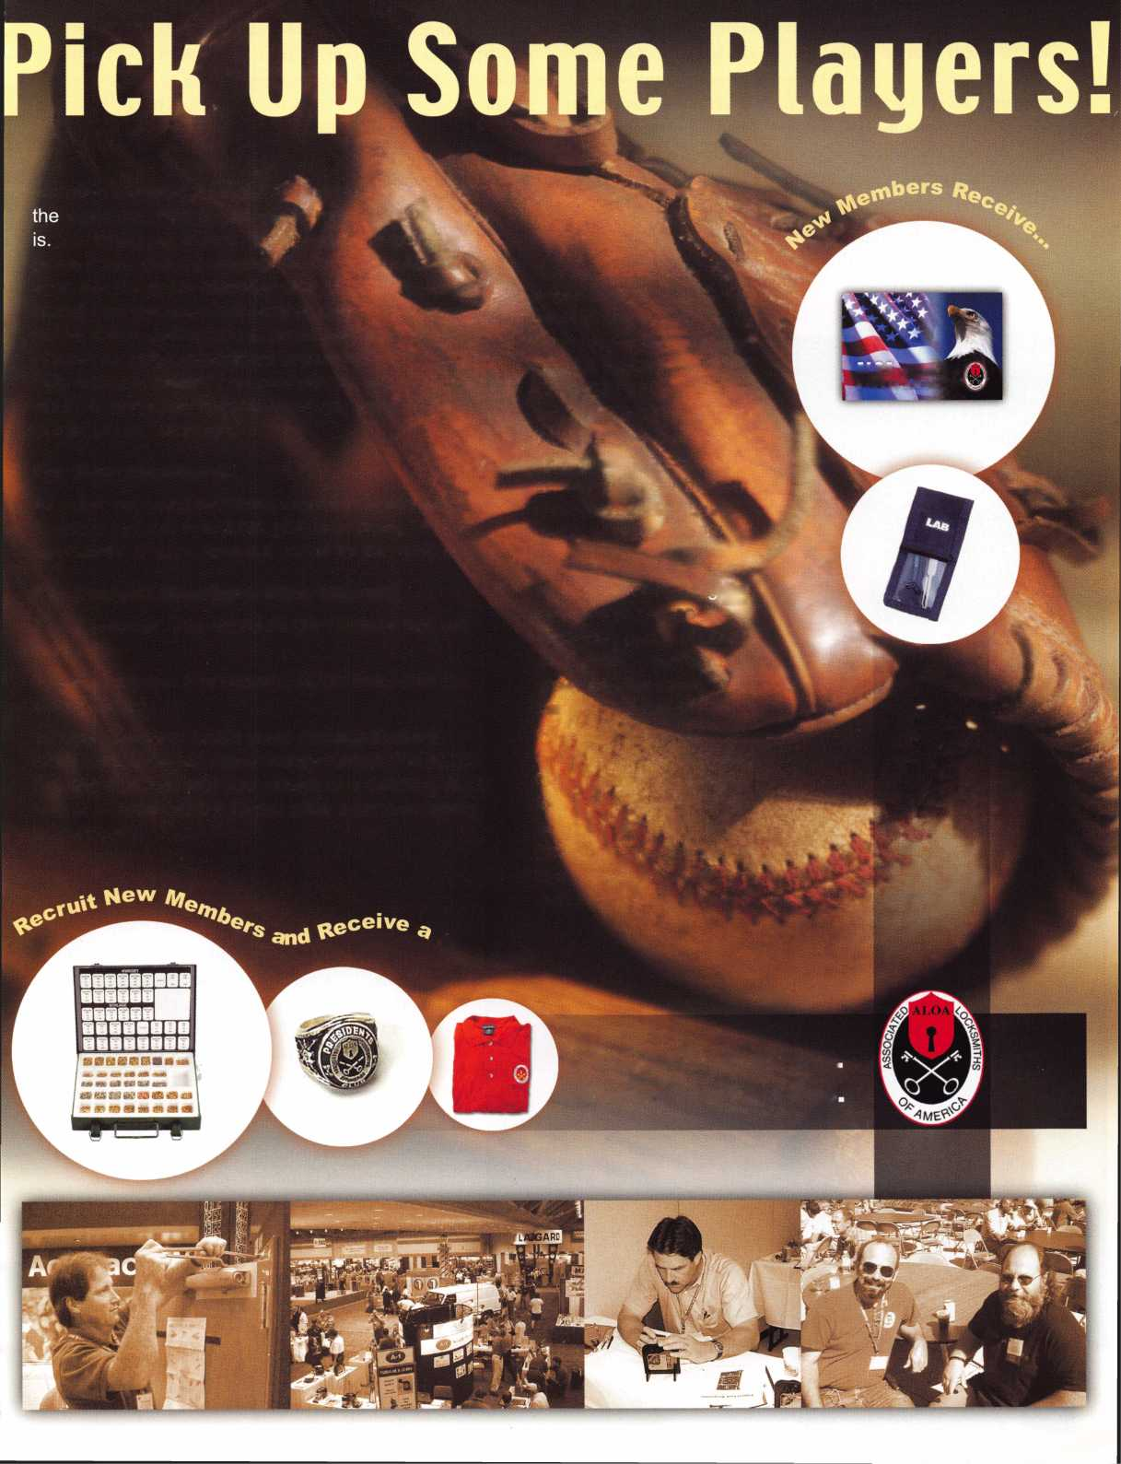

My recommendation was to contact Yale, let them know of the problem with excessive wear on the backs of the cylin­ders. I suggested they have the worst cylinders replaced with new ones, even if it had to be on an incremental basis, what­ever would work into their budget. The facility could also benefit from the new cylinders because there was noticeable wear on the existing pins. Repinning the existing cylinders was out of the question because of the severe wear.

All of that is well and good. Yet, so far, this is just some talk about locks and locksmithing in a medium security prison. BUT, what I experienced while inside the facility, beyond

As a result, they are, as you read this article, sit­ting in that medium security facility, thumping their fingers, just wasting their life away until their sentence is up and/or they get paroled. What a sad waste of life! Yes, I, of course, fully understand that these otherwise good people are there for committing crimes, and, as such, have to be where they are. You, and I, and all locksmiths, run into frustrating jobs. Those that should be a breeze, a piece of cake, but just wouldn’t go the way they should. The kind of job that can make you about ready to pull your hair out and scream something your mother definitely did not teach you.

Well, I made up my mind that when that kind of a job comes down the pike, I would imagine myself in the Jackson Correctional Facility If all I would have to do is finish the job at hand, do it right, get it ioo percent correct, and I could walk out a free man? I would get that job done right! So, I calm down, take a deep breath, re­think the situation, and then get it done. My blood pressure stays down where it should be, and so does my anger level.

My short time in prison (like in Monopoly, “just visiting!”), a single half of a working day, seeing all those (otherwise) nice guys, changed my life, and my attitude. That change of attitude has helped me when those #*@#!! jobs come along, as they will from time to time, for all of us. So, when “Caca Happens,” as it frequently does, because of the time I spent in prison, I know how to survive, and do so in a levelheaded and more relaxed manner. Even for a free man, prison definitely delivers an attitude adjust­ment. Q

locksmithing, changed my life. I am pleased to have this opportunity to share that valuable lesson with you: While walking around inside the medium security prison, escorted all the time by officials, I was frequently greeted by the inmates with, “Hi. How are you,” “Beautiful day,” and “How you been?” as well as other friendly greetings from some genuinely nice people that just happened to also be inmates. They were much like many of the men you would likely meet walking down any street in your hometown. All of them were pleasant, congenial individuals; the only differ­ence between them and some of the people in our home­towns is that they got caught.

Register NO\N for

Yankee

& Trade

**Education Classes**

and **Exhibition**

Security Conference

For more information, visit us online [www.yankeesecurity.org](http://www.yankeesecurity.org)

Yankee Security Conference

*The best locksmithing event in New England!*

NOVEMBER 6-10, 2002

**STURBRIDGE HOST HOTEL | STURBRIDGE, MA**

Keynotes • October 2002

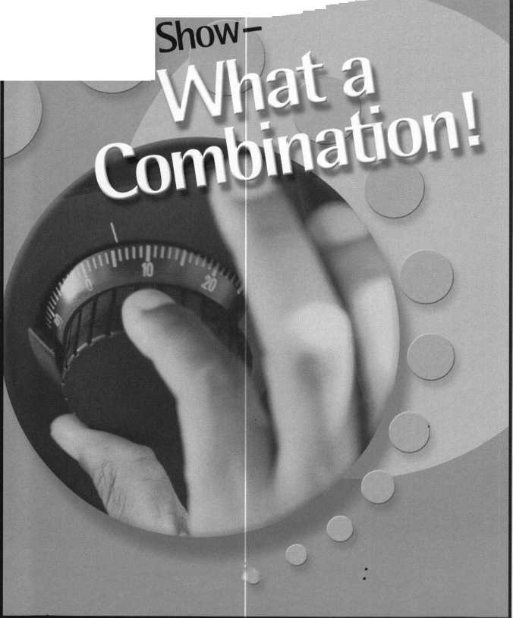

Yale® and Yale Security Inc.® are registered trademarks of Yale Security Inc. SecureX™ is a trademark of Yale Security Inc.

-

Sure, old Spike here will do the job. But you're going to have to feed him and walk him. SecureX'N our new patent pending controlled exit device with delayed egress, will stop anyone in their tracks without taking a bite out of their backside. It's the kind of product you've come to expect from Yale, one of the most respected names in the industry. So you have a decision to make. Contact us at 888-828-8349, or visit our website at [www.yalelocks.com](http://www.yalelocks.com) to find out more. Or go buy 50 lbs. of dry dog food.

Delayed Egress Exit Device

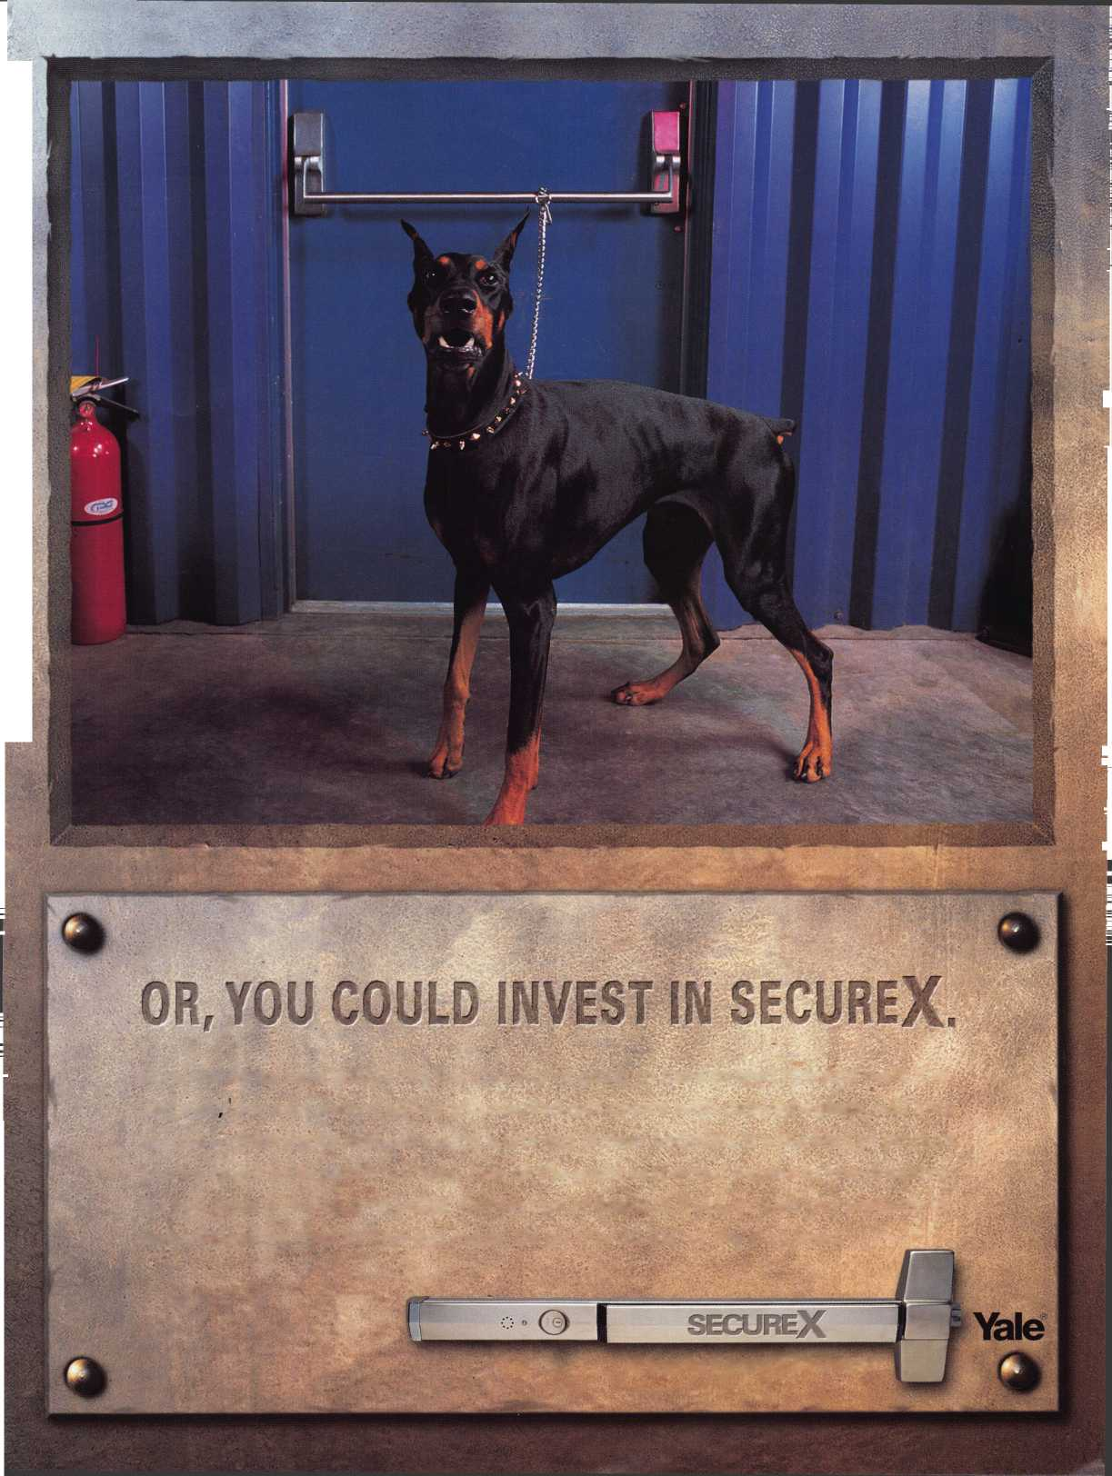

Give your advertising a boost! Your ad copy can mean the difference between profitable and unprofitable results from your marketing dollars. There are many ways to improve ad response for the security profes­sional. The following are offered as some tips that may help you achieve that goal.

ATTENTION-GRABBING HEADLINES

Headlines can affect response to your ads. Some pro­fessional copywriters spend more time on headlines than they do on all other elements of an ad combined. What is the purpose of a headline?

* To catch your targeted prospect’s eye
* To motivate him or her to continue reading the rest of the ad (or other type of marketing communication).

If the headline doesn’t do its job, the ad will most likely fail.

TARGET YOUR BEST PROSPECTS

Instead of trying to appeal to everyone with your headlines, target them toward the prime interest of your best prospects. There is little point in drawing the attention of those who have no interest in your offer.

ENCOURAGE PROSPECTS TO ACT “NOW”

Because people tend of delay action, ad response can be improved by making special limited-time offers that encourage potential customers to act now. Use a real deadline. For example, “Limited Supply-Place your order TODAY!” ‘Act now, and beat the holiday rush!”

GUIDE PROSPECTS THROUGH THE PROCESS

Your ads should include a clear “call to action”. This encourages your prospects to take action toward buy­ing your product and/or service. Make it unmistakably clear exactly what the next step is that potential cus­tomer should take in order to benefit from your prod­uct or service. For example:

* Call to place an order
* Call to request more information
* Stop by to see...

Whatever the next step in the sales process may be.

TEST AND REFINE YOUR APPROACH

For maximum response, constantly test and refine your ads in order to determine which approach(s) work best. Get feedback from your customers. Ask the customer, “How did you hear about us?” Some businesses use a code at the bottom of a coupon to see which ad was successful. Once you have a proven successful ad, you should continue enhancements to test further positive response.

BUILD AND USE AN AD FILE

Begin to create a collection of ads that appeal to your business sense. This is not limited to any specific type of business or limited to security-related ads. Creatively adapt the winning elements of other proven ads to your own situation. This beats trying to “reinvent the wheel” in advertising.

REAL-LIFE TESTIMONIAL

A customer satisfied with your products or services may allow you to use his or her testimonials in ad copy. (Permission must be granted!)

MAKE ADS LOOK NEWSORTHY

In some cases, ads that look like ads may draw less readership than those that look like editorial material. Think of ways you can take advantage of this in your marketing campaign, in order to increase response. For example, you can make them more informative, while doing an effective selling job.

KEEP IT SIMPLE

When writing ad copy, keep it simple. Break up long paragraphs and sentences into smaller ones and include only one main through per sentence.

Use bullet points. Streamline by cutting out unneeded words.

Give your advertising a boost! Clever, thought provoking ad copy can mean the difference between profitable and unprofitable results from your marketing efforts. D

Keynotes • October 2002



THIS IS AN IMPORTANT ELECTION YEAR - ESPECIALLY FOR LOCAL ELECTIONS

I would be remised in my duties as Government Affairs Manager if I didn't remind you that there is a very important General Election on Tuesday, November 5, 2002. Pay special attention to your local elections, because for locksmiths, it's the state elections that really count.

You probably know who your Congressman and Senators are, but do you know who your state Representative and state Senator are? How do they stand on licensing? Are they the chairperson of a committee that will consider any alarm licens­ing legislation that is introduced? Could they help you introduce locksmith licensing?

One of the best ways to know who your state rep­resentative is, would be to check the web. Go to <http://capwiz.com/asae/dbq/officials/> and click on your state. Enter your 5-digit zip + 4 (you'll probably have to run and get a bill if you don't know these numbers!), and click State, then GO. The site will then give you your state senator and representative. Better yet, it will give you a link to their websites. From their websites, you can see what kind of legislation they introduced or co-sponsored. The idea is to help support those candidates who are good on our issues. Your local ALOA chapter Affiliate or regional locksmith association will have insight on politicians who they may have a great working relationship.

While ALOA would never tell you who to vote for, it's nice to be an informed voter!

i s I a t i v e a t e

CONVENTION A WINNER FOR ALOA'S GOVERNMENT AFFAIRS DEPARTMENT!

On site information, a thank you luncheon, shar­ing ideas with other states and popcorn highlight­ed this year's legislative convention activities. The Legislative Booth, gave members a chance to find out what was happening at their state capitol that could effect their businesses, and of course, there was the every present aromatic popcorn given away!

The Legislative Action Network (LAN) Luncheon held Saturday afternoon gave everyone an opportunity to relax, and a way for ALOA to say, "THANK YOU" to all the Network members for going above and beyond the call of duty. A spe­cial presentation was made to the Legislative Action Network's Organization of the Year, Ohio Locksmith Association recognizing their hard work in getting a lobbyist and defeating the alarm association on harmful legislation. LAN Members of the Year awards recognized Lance Edwards, Dave Wells, CMST, CML, James Mullins, CPL, and Stephen Brown, CML for their hard work in Maryland on a last-minute locksmith registration bill. A LAN Member of the Year award was given to Mark Blum, CML, CPS for his generous support of the Legislative Action Network for the past five years. Updates on State legislative issues were presented including federal legislation, "The Motor Vehicle Owner's Right to Repair Act."

Once again we held the State of the States Roundtable also on Saturday, which was another great meeting for the exchange of information and ideas. There were 1 8 people in attendance (sometimes representing more than one associa­

Keynotes • October 2002

tion), including representatives from the Alabama Locksmith Association; Allied Locksmiths of Illinois; California Locksmith Association; Central & Southern Colorado Locksmith Association; Fox Valley Chapter (Wisconsin); Greater Philadelphia Locksmith Association; Indianhead Chapter (Wisconsin); Japan Chapter; Keystone Chapter (Pennsylvania); Korean Chapter; Maryland Locksmith Association/Chesapeake Chapter; Middle Tennessee Locksmith Association; Minnesota Chapter; North Coast Chapter (Ohio); Ohio Locksmith Association; Penn-Ohio Locksmith Association; Pennsylvania/Ohio Locksmith Association; Southern New Jersey Locksmith Association; Tennessee Organization of Locksmiths; Texas Locksmith Association; ALOA President Randy Simpson, CML; and ALOA Directors Julie McCluney, CRL; Robert Mock; and Gordon Racine, CML. Updated the group on State legislative issues, including fed­eral legislation, "The Motor Vehicle Owner's Right to Repair Act" and ALOA's involvement with the after-market industry. ALOA Executive Director Bill Gibson noted that when the bill passes and the regulations are drafted, that is when ALOA will make sure that information that locksmiths need to make keys is also made available. This meeting once again proved to be a great way to exchange information and ideas.

LEGISLATIVE UPDATE CALIFORNIA SB2026

Exempts a new motor vehicle dealer, as defined in Section 426 of the Vehicle Code, and employees of a new motor vehicle dealer acting within the scope of employment at a dealership from the Locksmith Licensing Act.

STATUS: 08/30/2002 Amended in Senate. Passed.

08/30/2002 Enrolled.

(NOTE: This provision was added in the form of an amendment on August 30th after it already had passed out of the House).

CHECK OUT ALOA'S  
WEBSITE AT  
<http://www.aloa.org>

**Aiews/legcom.cfm  
FOR THE LATEST  
HAPPENINGS IN  
YOUR STATE**



**SAFE CORPORATION**

MANUFACTURES OF QUALITY DEPOSITORY SAFES AND CHESTS

DISTRIBUTING FROM WAREHOUSES IN

* LOS ANGLES, CA
* CHICAGO, IL
* GLASSBORO, NJ

A & B is now a stocking distributor

for Mutual Safes

AB-4-30-3S AB-9-2 WS 10-2

Chose from over 75 models in stock

We ship your order within

24 hours

See us

*ot [www.o-bsofecorp.com](http://www.o-bsofecorp.com)*800-253-1267  
Fax 856-863-1208

CALL FOR YOUR  
CATALOG TODAY

B

Keynotes • October 2002

**3**

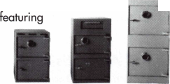

EMPLOYMENT

STOP LOOKING!!!!!

EXPERIENCED TECHNICIANS WANTED

Lock into your future now! If you are experienced, intelligent, and desire a secure future, come join our team. We are a full service commercial/resi- dential security service (locks, keys, safes, cctv, access control, door related hardware). We offer: sign on bonus, top wages,company vehicle, 401 k, paid vacation, paid holidays, new uniforms, cross training, and job satisfaction.We are looking for the best tech's, who are ready to be treated and compensated as professionals.

Bass Security Services, Inc.

Ph#216-755-1 200 ex.# 128

Fax#216-755-1 220

E-MAIL/ [rmesnick@bass-security.com](mailto:rmesnick@bass-security.com)

LOCKSMITH, FULL TIME POSITION.

Southern California location, commercial/industrial work, no automotive. Earn $2,400 - 3,520 per month plus benefits. Minimum 2 years experience and clean DMV. We are a professional company specializing in commercial and industrial security.

We also sell, install and service, CCTV, access con­trol, and monitored alarm systems. Please contact Dan or Curt @ 714-632-5558.

LOCKSMITH WANTED

Busy shop in Woburn, MA, has immediate opening for a self-motivated, reliable locksmith. Large cus­tomer databases for automotive, AAA, commercial and residential accounts. Applicants with own van and tools are guaranteed 50 percent commission. We can also supply van and tools. A great oppor­tunity for the right individual. All inquiries are kept strictly confidential. Send resume to: Locks & Keys Inc. P.O. Box 222, Woburn, MA, 01801. E-mail: [jobs@locks-keys.com](mailto:jobs@locks-keys.com). Or call John at 781/933- 9999.

EXPERIENCED TECHNICIAN WANTED

Residential/Commercial/Experienced Automotive locksmith wanted. Rapidly growing, well-estab­lished Houston firm looking for good men capable of handling all types of lock work. Must have own tools and transportation. Excellent pay and other benefits provided. Apply at 281/497-5555 or FAX 713/975-7534.

Classified Advertising Policy

Classified advertising space is provided free of charge to ALOA members, and fora fee of $.60 per word, $ 15 minimum for non-members. Classified ads may be used to advertise  
used merchandise and overstocked items for sale, "wanted to buy" items, business opportunities, employment opportunities/positions wanted and the like. Members or non-members wishing  
to advertise services or new merchandise for sale may purchase a "Commercial Classified Ad," for a fee of $1.30 per word, with a minimum of $40. Each ad will run for two issues. For blind  
boxes there is a $5 charge to members and non-members. All ads must be submitted in writing to the ALOA office by the fifteenth of the month, two months prior to issue date. Send to  
Keynotes Classifieds, 3003 Live Oak St., Dallas TX 75204-6186. ALOA reserves the right to refuse any classified advertisement that it deems inappropriate according to the stated purpose

of the classified advertising section.



/

Keynotes • October 2002



COMPANY IN SEARCH OF A LOCKSMITH

with a Top Secret security clearance with experience in X07/X08 systems. This is a immediate opening in the Northern Virginia area with a salary of $45-50K and a comprehensive benefit package. Interested candidates should e-mail resume and cover letter as an MS Word attachment to Michael W. Banks • Executive Vice President & COO • ZKD Inc. • office 703-243-8744 fax 703-243-7747 • cell 240-216-4728 [www.zkdinc.com](http://www.zkdinc.com)

BUSINESS FOR SALE

Established, 30-year " award winning " lock and safe business in rural eastern Connecticut for sale. Brisk retail store, new service vehicle, safe rigging truck and over $250,000 in equipment and inventory.

This is a five-day work week business that nets the husband and wife team a nice six-figure income plus benefits. Commercial and residential only - no autos. Selling every­thing at a steal price of $200,000. The hard work is already done ; just take over and run. Hundreds of solid, long-established accounts, only locksmith in large area.

Fax us at 860/423-5604 with your name and address and your interest. We will send you an information packet about the business, complete with photos. If you have equi­ty, we can help with local financing.

BUSINESS FOR SALE

Well-established locksmith business in California. Grosses $140K per year. Priced at $75K. No outstanding loans on business. 80 percent income from existing accounts. Included in price: well-maintained 94 F250 Locksmith van, equipment to work out of both vans, plus furnish a separate work area and lots and lots of stock. FAX 949/458-1733 for an immediate response from us, or call Keynotes classi­fieds at 800/532-2562, ext. 19, and leave your informa­tion so we can contact you. Thanks.

FOR SALE:

Mobile lock shop equipped with $4000. Write or call Anthony Rossi, 45055 East Florida Ave., Hemet, CA, 92544. Phone 909/927-6858.

WORK WANTED

SECURITY PRO FOR HIRE

CML, CPS seeks a challenging and personally rewarding position as a Locksmith at the supervisor or management level. Would prefer institution or college in the Midwest or central United States, however all locations would be con­sidered. 30+ years in the field and well versed in all aspects of sales, training and management. Please respond to the editor of ALOA, (800)532-2562, ext. 19.

WANTED TO BUY/SELL

FOR SALE:

Overstock: one llco pin kit #796-008X, $150; three Von Duprin 9927F US28 w/o trim, $300 each; eight Von Duprin 9927TP 3' 313, $450; 22 Von Duprin 88EO No trim, $200 each. Plus, used merchandise: llco model 2178U universal code machine, depth guide .015, .18, .020, .023, spacing guide .150 and .156. Cutter 20 MC, 14 MC + 1, $400. All items are plus shipping. Key machines: Sugar Model SA 400, First key — $400; Medeco manual cuts "00" commercial keys — $1500; Medeco pneumatic complete with air compressor cuts "00" commercial keys — $2000.

E-mail: [jcrenderer@aol.com](mailto:jcrenderer@aol.com), or call 305/944-0469.

FOR SALE:

Locksmith tools, code books, hardware, key blanks. Framon, Curtis, Aero, Schlage, LSDA. For complete list, contact Gary at P.O. Box 52, Conover, Wl, 54519, phone 330/41 8- 1689 or e-mail: [gary@cybertekweb.com](mailto:gary@cybertekweb.com), view complete list on web at [www.cybertekweb.com/tools](http://www.cybertekweb.com/tools).

CURTIS #14A CODE CUTTER CARRIAGES:

Ford 2, Chry3, AM2, Ford 3, Chry2, DC1, AMI, DM30, Chryl, Toy4, HD9A, Toy3, Toy2, Dyl, DMN, HD4A, GM2, GM1, HD4B, Toyl, GM2X. Cams: GM1, Chryl, Chry2, Ford3, Ford 1, Ford 2. Key gauges: GM, Ford, Chrysler, AMC, Toyota. Curtis Code books for older model: GM 1935-82, Honda Nissan, Mazda, Ford 5-pin and 10 cut, AMC, Chrysler. $400, shipping included. Call Precision Lock Service at 330/41 8-1689, or e-mail to: [gary@cybertekweb.com](mailto:gary@cybertekweb.com).

FOR SALE

Abloy Key machines for sale. One brown, one blue. Also, misc. Abloy cyl., Abloy keys, Abloy parts. Medeco Sky II and Standard deadbolt, knob cyl., and misc. Make offers, whole or part. Call 561/746-6404.

WANTED TO BUY

Wanted: Original Hurd and Briggs & Stratton auto key blanks. I will pay $1 each. Send me a list of what you have. Write to: Douglas Vogel, 4779 Meadowlark Ln., Dexter, Ml, 48130.

**41**

Keynotes • October 2002

|  |  |  |  |  |
| --- | --- | --- | --- | --- |
| pn  f | a | s s | o c i a 1 | t e |
| M |  | m | embers |  |

Distributor

ADI Inc.

Phone: 631-692-1000 Fax: 631-692-3011

Accredited Lock Supply Co.

Phone: 201-865-5015 Fax: 201-865-0030 [www.acclock.com](http://www.acclock.com)

Ace Lock & Security Supply

Phone: 908-688-7666 Fax: 908-688-2442 [www.acelock.com](http://www.acelock.com)

Action Hardware Inc.

Phone: 800-662-6695 Fax: 800-930-2329

Andrews Wholesale Lock Supply

Phone: 717-272-7422 Fax: 717-274-8659

Boyle & Chase Inc.

Phone: 800-325-2530 Fax: 800-205-3500 [www.boyleandchase.com](http://www.boyleandchase.com)

Clark Security Products

Phone: 800-854-2088 Fax: 619-974-5284 [www.clarksecurity.com](http://www.clarksecurity.com)

Cook's Building Specialties

Phone: 505-883-5701 Fax: 505-883-5704

Dire's Lock & Key Company

Phone: 303-294-0176 Fax: 303-294-0198

Direct Security Supply; Inc.

Phone: 800-252-5757 Fax: 800-452-8600

Doyle Security Products

Phone: 800-333-6953 Fax: 612-521-0166 [www.doylesecurity.com](http://www.doylesecurity.com)

Dugmore and Duncan, Inc.

Phone: 888-384-6673 Fax: 888-329-3846

E. L. Reinhardt Co., Inc.

Phone: 800-328-131 1 Fax: 651-481-0166 [www.elreinhardt.com](http://www.elreinhardt.com)

Ewert Wholesale Hardware

Phone: 800-451-0200 Fax: 708-597-0881

Fairway Supply, Inc.

Phone: 214-350-0021 Fax: 214-352-4299 [www.fairwaysupply.com](http://www.fairwaysupply.com)

Foley-Belsaw Company

Phone: 800-821-3452 Fax: 816-483-5010 [www.belsaw.com](http://www.belsaw.com)

Fried Brothers Inc.

Phone: 800-523-2924 Fax: 215-592-1255 [www.fbisecurity.com](http://www.fbisecurity.com)

H L Flake Co

Phone: 800-231-4105 Fax: 713-926-3399 [www.hlflake.com](http://www.hlflake.com)

H.S. & S. Wholesale Distrib.

Phone: 313-342-6777 Fax: 313-342-7580

Hans Johnsen Company

Phone: 214-879-1550 Fax: 214-879-1530

Hardware Agencies, Ltd.

Phone: 416-462-1921

Howard Keys

Phone: 704-509-4944 Fax: 704-509-6248 [www.howardkeys.com](http://www.howardkeys.com)

IDN Incorporated

Phone: 817-421-5470 Fax: 817-421-5468

Intermountain Lock & Supply

Phone: 800-453-5386 Fax: 801-485-7205 [www.intermountainlock.com](http://www.intermountainlock.com)

Jo Van Distributors

Phone: 416-752-2238 Fax: 416-752-7282

Lockmasters, Inc.

Phone: 859-885-6041 Fax: 859-885-7093 [www.lockmasters.com](http://www.lockmasters.com)

Locks Company

Phone: 800-288-0801 Fax: 305-949-3619

M. Zion Company

Phone: 212-349-8677 Fax: 212-964-0495

Massglass &

Door Service

Phone: 888-742-8837 Fax: 818-991-5742 [www.massglass.com](http://www.massglass.com)

McDonald Dash Locksmith Supply

Phone: 800-238-7541 Fax: 901-366-0005 [www.mcdonalddash.com](http://www.mcdonalddash.com)

McManus Locksmith Supply, Inc.

Phone: 704-333-9112 Fax: 704-332-8664

Monaco Lock Co.

Phone: 800-526-6094 Fax: 800-845-5625 [www.monacolock.com](http://www.monacolock.com)

Omaha Wholesale Hardware

Phone: 800-238-4566 Fax: 402-444-1664 [www.omahawh.com](http://www.omahawh.com)

Phoenix Safe International LLC

Phone: 765-483-0954 Fax: 765-483-0962 [www.phoenixsafeusa.com](http://www.phoenixsafeusa.com)

RA-Lock Company

Phone: 972-775-6301 Fax: 972-775-6316 [www.ralock.com](http://www.ralock.com)

SecureRite.Com

Phone: 800-241-3930 Fax: 858-974-5269 [www.SecureRite.Corn](http://www.SecureRite.Corn)

Sentry Security Fasteners

Phone: 309-693-2800 Fax: 800-693-2872

Somerset Security Products

Phone: 800-881-5206 Fax: 800-206-9949

Southern Lock and Supply Co.

Phone: 727-541-5536 Fax: 727-544-8278 southernlock.com

Stone & Berg Wholesale

Phone: 800-225-7405 Fax: 800-535-5625

Taylor Security & Lock

Phone: 301-948-7670 Fax: 301-948-1029 [www.taylorsecurity.com](http://www.taylorsecurity.com)

The Locksmith Store Inc.

Phone: 847-364-5111 Fax: 847-364-5125 [www.locksmithstore.com](http://www.locksmithstore.com)

Timemaster Inc.

Phone: 888-798-8465 Fax: 800-798-8463 [www.ti](http://www.ti) m e-master, com

Top Notch Distributors, Inc.

Phone: 800-233-4210 Fax: 800-854-4146 [www.4topnotch.com](http://www.4topnotch.com)

U.S. Lock Corp.

Phone: 800-925-5000 Fax: 800-338-5625 [www.uslock.com](http://www.uslock.com)

Webster Safe & Lock Co., Inc.

Phone: 901-332-2911 Fax: 901-332-2878 webstersinc.com

Manufacturer

A & B Safe Corporation

Phone: 800-253-1267 Fax: 856-863-1208 [www.a-bsafecorp.com](http://www.a-bsafecorp.com)

ABUS Lock Company

Phone: 800-352-2287 Fax: 602-595-3499 [www.abus.com](http://www.abus.com)

Abloy Door Security

Phone: 800-465-5761 Fax: 514-335-0430 [www.abloy.com](http://www.abloy.com)

Adams Rite Mfg. Company

Phone: 800-872-3267 Fax: 800-232-7329 [www.adamsrite.com](http://www.adamsrite.com)

Adesco Safe Mfg. Company

Phone: 800-821-6803 Fax: 562-408-6427 [www.adesco.com](http://www.adesco.com)

Adrian Steel Company

Phone: 800-677-2726 Fax: 517-265-5834 [www.adriansteel.com](http://www.adriansteel.com)

Alarm Lock Systems Inc.

Phone: 800-252-5625 Fax: 516-789-3383 [www.alarmlock.com](http://www.alarmlock.com)

All Five Tool Company, Inc.

Phone: 860-583-1691 Fax: 860-583-4516 [www.all5tool.com](http://www.all5tool.com)

American Lock Company

Phone: 708-534-2000 Fax: 708-534-0531

American Security Products

Phone: 909-685-9680X1083 Fax: 909-685-9685 [www.amsecusa.com](http://www.amsecusa.com)

BWD Automotive

Phone: 334-872-6524 Fax: 334-874-6011 [www.bwdautomotive.com](http://www.bwdautomotive.com)

Baldwin Hardware

Phone: 610-796-4012 Fax: 610-796-4493

Be-Tech Security Systems Ltd.

Phone: 852-231-67447 [www.be-tech.com.hk](http://www.be-tech.com.hk)

Buddy Products

Phone: 800-886-8688 Fax: 312-733-8356 [www.buddyontheweb.com](http://www.buddyontheweb.com)

COMPX Security Products

Phone: 864-297-6655 Fax: 864-297-9987 [www.nclnet.com](http://www.nclnet.com)

Curtis Industries,

A Barnes Distr.

Phone: 800-555-5397 Fax: 800-867-6020 [www.curtisindustries.com](http://www.curtisindustries.com)

Keynotes • October 2002

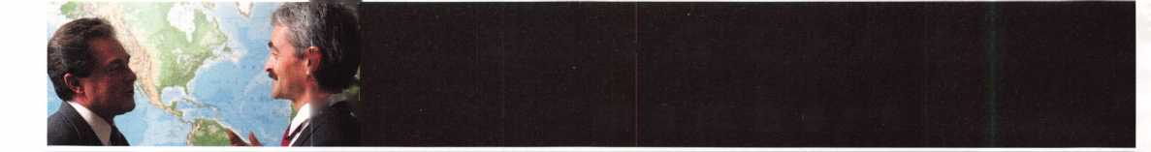

**associate**

**members**

D&D Technologies (USA), Inc.

Phone: 714-677-1300 X292 Fax: 714-677-1299 [www.ddtechusa](http://www.ddtechusa) .com

DETEX Corporation

Phone: 800-729-3839 Fax: 830-620-6711

DORM A Architectural Hardware

Phone: 717-336-3881 Fax: 717-336-3500 [www.dorma-usa.com](http://www.dorma-usa.com)

Don-Jo Manufacturing, Inc.

Phone: 978-422-3213 Fax: 978-422-3467 [www.don-jo.com](http://www.don-jo.com)

Door Controls International

Phone: 800-742-3634 Fax: 800-742-0410

[www.doorcontrols.com](http://www.doorcontrols.com)

ESP Lock Products Inc.

Phone: 978-562-3481 Fax: 978-562-9859

FireKing Security Products

Phone: 800-457-2424 Fax: 800-896-6606 [www.fireking.com](http://www.fireking.com)

HES, Inc.

Phone: 623-582-4626 Fax: 623-582-4641 [www.hesinnovations.com](http://www.hesinnovations.com)

HPC, Inc.

Phone: 847-671-6280 Fax: 847-671-6343 www. h pc wo r I d .com

Hongtai Lock Co. Ltd.

Phone: 137-238-1414 Fax: 208-793-3856

INTELLIKEY Corp.

Phone: 800-226-0703 Fax: 321-724-0811 [www.intellikey.com](http://www.intellikey.com)

llco Unican

Phone: 252-446-3321 Fax: 252-446-4702 [www.kaba-ilco.com](http://www.kaba-ilco.com)

Jet Hardware Mfg., Co.

Phone: 718-257-9600 Fax: 71 8-257-0973

KABA High Security Locks

Phone: 860-621-3601 Fax: 860-621-9727 [www.kabausa.com](http://www.kabausa.com)

KEY-BAK/West Coast Chain Mfg.

Phone: 909-923-7800 Fax: 909-923-0024 [www.keybak.com](http://www.keybak.com)

Keri Systems Inc.

Phone: 408-451-2520 Fax: 408-441-0309 [www.kerisys.com](http://www.kerisys.com)

Knaack Manufacturing Co.

Phone: 800-456-7865 Fax: 815-459-9097 [www.weatherguard.com](http://www.weatherguard.com)

LAB Security

Phone: 800-243-8242 Fax: 860-583-7838 [www.labpins.com](http://www.labpins.com)

LCN Closers/Div. of Ingersoll

Phone: 815-875-331 1 Fax: 815-879-1497 [www.lcnclosers.com](http://www.lcnclosers.com)

La Gard Inc.

Phone: 310-325-5670 Fax: 310-325-5615 [www.lagard.com](http://www.lagard.com)

Locksmith Ledger International

Phone: 770-886-0800 Fax: 770-889-7703 lledger.com

Lucky Line Products, Inc.

Phone: 858-549-6699 Fax: 858-549-3241

M.A.G. Security

Phone: 714-891-5100 Fax: 714-892-6845 [www.magsecurity.com](http://www.magsecurity.com)

MARKS, U.S.A.

Phone: 516-225-5400 Fax: 516-225-6136 [www.marksusa.com](http://www.marksusa.com)

MARRAY Enterprises

Phone: 408-970-0213 Fax: 408-970-8767 [www.marray.com](http://www.marray.com)

MCS Communication Systems

Phone: 514-444-2040 Fax: 514-444-2029 [www.mcscommunication.com](http://www.mcscommunication.com)

MMD, Inc.

Phone: 865-428-361 1 Fax: 865-453-4136

MUL-T-LOCK USA, Inc.

Phone: 800-562-351 1 Fax: 973-778-4007 [www.mul-t-lock.com](http://www.mul-t-lock.com)

Master Lock Company

Phone: 414-444-2800 Fax: 414-444-0322 [www.masterlock.com](http://www.masterlock.com)

Medeco Security Locks

Phone: 540-380-5000 Fax: 540-380-5010 [www.medeco.com](http://www.medeco.com)

NKL Industries Inc.

Phone: 800-528-9900

Fax: 757-485-0271

www.nklindustries.comproducts_NK

Pro Steel

Phone: 801-373-2385 Fax: 801-373-2399

[www.pro-steel.net](http://www.pro-steel.net)

ROFU International Corp.

Phone: 800-255-7638 Fax: 253-922-1728 [www.rofu.com](http://www.rofu.com)

Rutherford Controls Int'l Co.

Phone: 757-427-1230 Fax: 757-427-9549 [www.rutherfordcontrols.com](http://www.rutherfordcontrols.com)

STRATTEC Security Corp.

Phone: 414-247-3415 Fax: 414-247-3692

Sargent & Greenleaf, Inc.

Phone: 859-885-941 1 Fax: 859-885-3063 [www.sglocks.com](http://www.sglocks.com)

Sargent Manufacturing Co.

Phone: 203-562-2151 Fax: 203-776-5992

Schlage Lock Co.

Phone: 719-264-5300 Fax: 719-264-5382 [www.schlagelock.com](http://www.schlagelock.com)

Schwab Corp.

Phone: 765-447-9470 Fax: 765-447-8278 www. schwa bcorp .com

Securitron Magnalock Corp.

Phone: 775-355-5626 Fax: 775-355-5636 [www.securitron.com](http://www.securitron.com)

Security Door Controls

Phone: 805-494-0622 Fax: 805-494-8861 [www.sdcsecurity.com](http://www.sdcsecurity.com)

Security Solutions

Phone: 405-376-1600 Fax: 405-376-6870

Sentry Group

Phone: 716-381-4900 Fax: 716-381-8559 www. sen try sa fe .com

Sully Tools Inc.

Phone: 703-689-3416 Fax: 703-787-0869 [www.sullytools.com](http://www.sullytools.com)

SunSafes Manufacturing Co.

Phone: 823-194-59300 Fax: 823-194-59400

[www.eaglesafes.com](http://www.eaglesafes.com)

Taymor Industries, Inc.

Phone: 800-388-9887 Fax: 800-288-8133 Trine Access Technology Phone: 718-829-2332 Fax: 718-829-6405 [www.trineonline.com](http://www.trineonline.com)

Videx Inc.

Phone: 541-758-0521 Fax: 541-752-5285 [www.videx.com](http://www.videx.com)

W-LOK Corporation

Phone: 616-355-4015 Fax: 616-355-4295

[www.wlokcorp.com](http://www.wlokcorp.com)

Yale Security Group, Inc.

Phone: 800-438-1951 Fax: 800-338-0965

Service Organization

1 -800 Locksmith 1994 Inc.

Phone: 800-562-5764 Fax: 718-236-4504 www. 1 800locksmith.net

Allstate Insurance Company

Phone: 847-402-8196 Fax: 847-326-7509 [www.allstate.com](http://www.allstate.com)

Emergency Road Service Inc.

Phone: 888-839-5386 Fax: 678-277-8105

Professional Business Products

Phone: 248-360-3979 Fax: 248-360-3982

The National Locksmith

Phone: 630-837-2044 Fax: 630-837-1210

[www.thenationallocksmith.com](http://www.thenationallocksmith.com)



Keynotes • October 2002

**back page**

About the Authors

Sal Dulcamaro, CIVIL, has been in the security industry for over 26 years. He is the president of All Pro Security, Inc. in Michigan and has been an ALOA member for 19 years. A past presi­dent of the Locksmith Security Association of Michigan, Sal currently serves as web editor of the association's on-line newsletter. He was named Keynotes "Author of the Year" in both 1996 and 1997. He is also a contributing editor for Keynotes. Find Sal on the Internet at: <http://www.home>. earthlink.net/-lockwriter.

Claire Cohen, the second woman to become a CML, has been in locksmithing since 1977, and has been writing articles for Keynotes since 1987. She is also a contributing editor for Keynotes, and received the 2001 Keynotes Author of the Year Award - again, only the second woman to achieve that honor.

Greg Perry, CML, CPS has been in the locksmith indus­try for 20 years. He's spent half of that time as a field technician for Security Engineering in Ridgecrest, CA. Greg is also a past president of the Desert Counties Chapter of the California Locksmiths Association. He has also won the 2002 Keynotes Author of the Year Award. You can e-mail him at [glmperry@iwvisp.com](mailto:glmperry@iwvisp.com)

Tom Seroogy is in the new Automotive division of Lockmasters. He has been the Product Manager for BWD Automotive (formerly known as All Lock). His many years of technical expertise in the automotive field and as a con­tributor to automotive locksmith education have created a much sought after demand for his popular classes. Tom has developed the new Automotive Locksmithing I & II classes for ALOA to help prepare locksmiths for the PRP automotive electives.

David E. Thielen, CML is the lockshop manager for Adams Twelve Five Star School District, Broomfield, Colorado. He has been a professional locksmith for more than 15 years a member of RMLA and DHI and a member of ALOA since 1985. He has instructed classes for the Rocky Mountain Locksmiths Association and has devel­oped and instructed ACE certified classes for ALOA at regional and national conventions.

|  |  |
| --- | --- |
| r |  |
| Ad Index |  |
| Kaba Mas Inside Front Cover | |
| ALOA 2003 | 1 |
| DHI | 5 |
| Lockmasters | .13 |
| Professional Business Products | .25 |
| Sanzo | .31 |
| Yankee Security Conference | .34 |
| Yale | .35 |
| A&B Safe Corp | .39 |
| Safetech Inside back Cover | |
| Hickok Back Cover | |
| L |  |



Keynotes • October 2002

**HE**

**IN SAFETE**

THE SAFE AND VAULT T

aCHNICIANS ASSOCIATION

CONVENTION

TRADE SHOW

MARCH

**24-29**

BAHIA RESORT HOTEL •

SAN DIEGO, CALIFORNIA

GATE

**Future**

**CHNOLOGY**

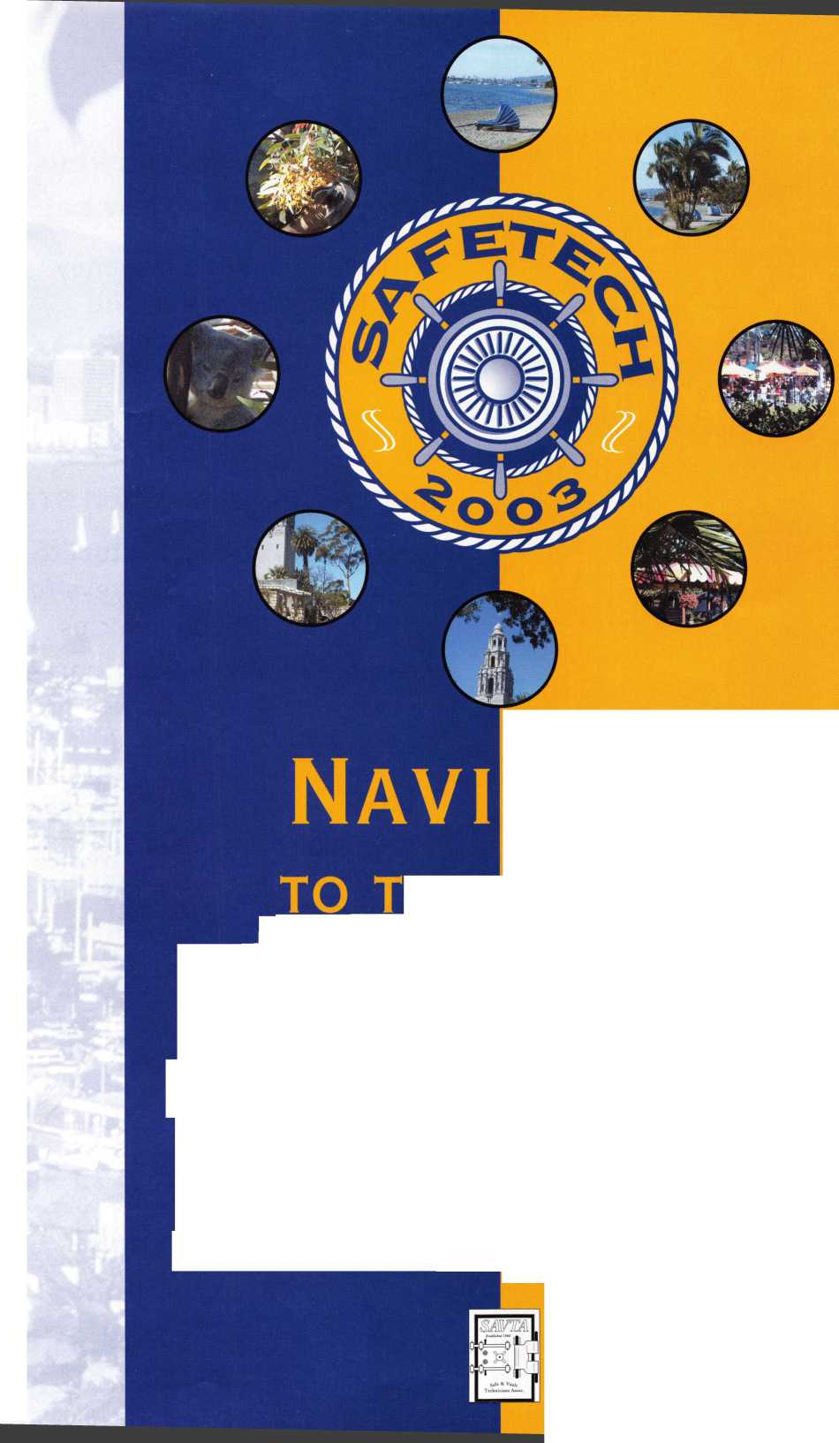

**You're never on your own..**

**Toll Free Tech Support**

**1-800-342-5080**

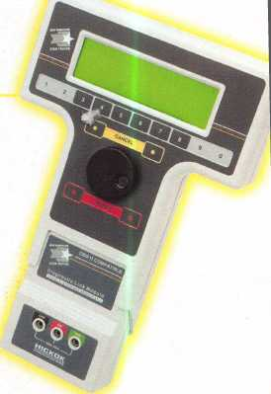

I've lost my Taurus keys.

can you make a new set?

*

How much of your money  
have you sent to the  
local Ford dealer?

8008LA New Generation STA|

Use the Ford factory tool to program transponder keys for| ALL Ford/Mazda vehicles.

Keep the money in your pocketI

Complete

Ford/Mazda

transponder

coverage

NGS

PLUS the

ability to clear ALL

Diagnostic

Service Codes

Say "YES" to  
$100 phone calls



HICKOK

for more information visit

**[www.hickok-inc.com](http://www.hickok-inc.com)**

INCORPORATED

